
Scratch – Lesson 2
Name:

 | Questions to answer

Explain what this code does.
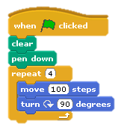

___________________________________________________________

___________________________________________________________

___________________________________________________________

___________________________________________________________

What shape will the following create?

Number of repeats | Angle | Shape
360 | 1
3 | 120
8 | 45

What is the difference between the repeat and the forever loop?

___________________________________________________________

___________________________________________________________

___________________________________________________________

___________________________________________________________

