Class 7 Science WB 13.07.20
In the final 2 weeks of home learning, we are going to recap a few science topics we covered earlier in the year.
1: Sound  Follow the link below:  https://www.bbc.co.uk/bitesize/articles/zb4jcmn  • Read the introductory points about sound  • Watch the 3 short video clips  • Complete the ‘fill in the gaps’ activity (Activity 1)  • Complete the quiz activity (Activity 2) | 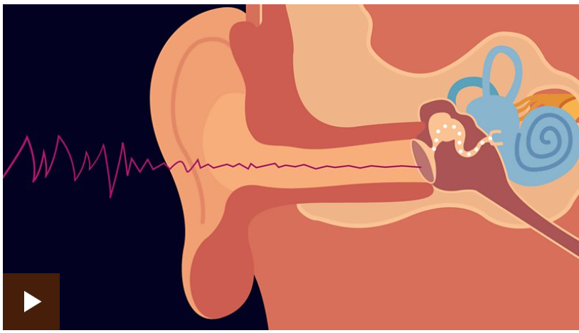
2: Electricity (renewable and non-renewable energy)  Follow the link below:  https://www.bbc.co.uk/bitesize/articles/zm9jmyc  - Watch the video clip about renewable energy and read the information  - Watch the video clip about non-renewable energy and read the information  - Watch the recap video  - Complete the ‘fill in the gaps’ activity (Activity 1)  - Complete the quiz activity (Activity 2) | 

