Class 7 Science WB 6th July 2020
Animals including humans
Food Chains

- Watch the video clip about food chains:  https://www.bbc.co.uk/bitesize/articles/zhnny9q | 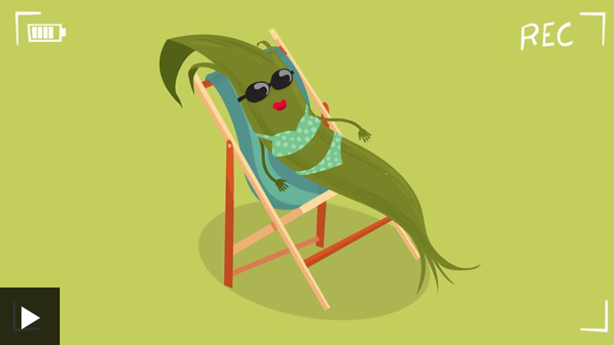
- Read the information about producers and consumers: | 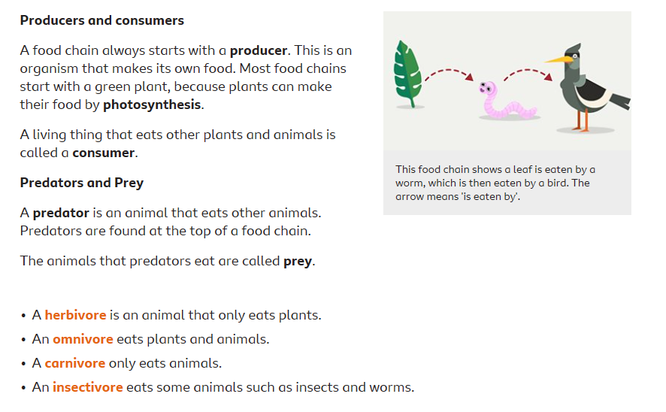
- Complete the 3 ‘Food Chain Challenge’ activities (Savannah, Tunda, Woodland) | 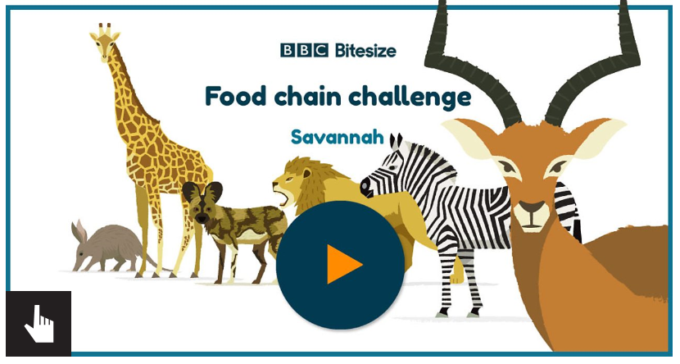
- Using your knowledge from session 1 this week, complete the following activities (still on the same link as above):  - ‘Reorder’ – Put the food chain in the correct order.  - Food chain quiz. | 

