Class 7 Science
WB 29.06.20

1: Click through the information slides and animations about how to look after your teeth. Then, take the quiz!  https://www.childrensuniversity.manchester.ac.uk/learning-activities/science/teeth-and-eating/looking-after-your-teeth/ | 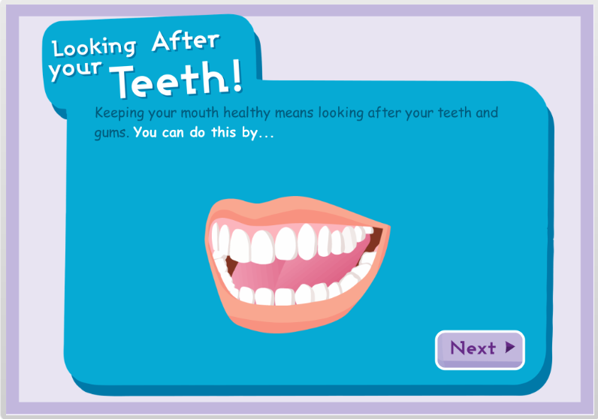
2: Use the activity from session 1 to gather some key information about how to look after your teeth. Present this in an information poster, containing the following features:
- Bold, bright heading
- Key facts
- Labelled diagrams
- ‘Did you know?’ surprising fact

