Class 7 Science WB 22.06.20: Teeth

Activity 1: Watch the following science clip all about teeth:  https://www.bbc.co.uk/teach/class-clips-video/science-ks2-teeth-how-they-help-animals-eat/zr8ygwx | 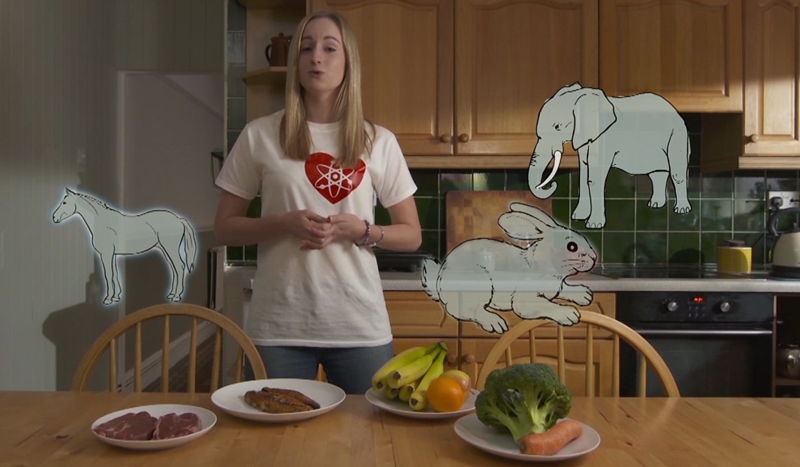
Activity 2: Answer the following questions:
1. What is an omnivore?
2. Give 2 examples of carnivores, as stated in the video clip.
3. What would happen if you just had a mouthful of molars?
4. Why do humans have a combination of teeth types?
5. What are incisors for?
6. Which teeth crush and break food?
7. What do a horse’s front teeth do?
8. What can herbivores and omnivores do with their jaws that carnivores can’t?
9. What is the number 1 cause of tooth decay in human?
10. In the egg experiment, what happened to:
• The egg in water?
• The egg in cols?
• The egg in vinegar?
Activity 3:  Build a mouth using this interactive game:  https://www.childrensuniversity.manchester.ac.uk/learning-activities/science/teeth-and-eating/build-a-mouth/  Drag the different types of teeth into the correct positions to complete the mouth! | 

