Class 7 Science WB 1st June 2020
Animals including humans.

Let’s continue our research of the digestive system!

1 – Digestive system word search. Can you have a think about what each bit of the digestive system does? | 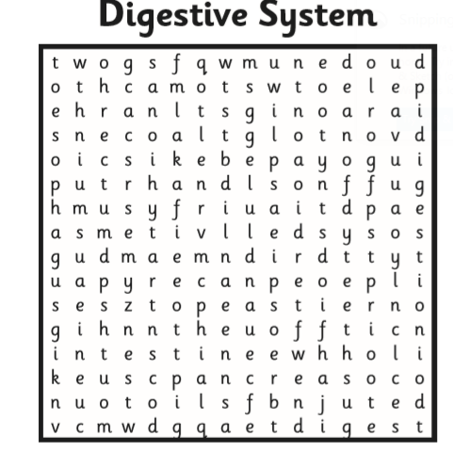
2 – Read the explanation text about the different parts of the digestive system. Answer the questions as fully as you can. | 

