Class 7 Science Year 3 and Year 4.
Wb 25.05.20
The Digestive System
Animals including humans – Have a read through the Knowledge Organiser for this unit of work? This covers all the key facts for this science topic.

Instructions:
Session 1 – Work though the powerpoint slides. Have a go at naming the parts of the digestive system.  Look at the ‘Comparing digestive systems’ sheets. Don’t worry if you can’t print off the table – draw your own. Try the 2 star challenge here. Compare the digestive systems of the bird and the cow. Note down in the table the parts that are the same and the parts that are different. | 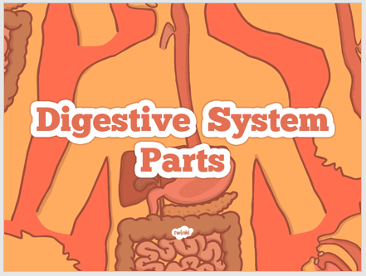
Session 2 – Answer the questions on the 3 star challenge sheet. | 

