Class 7 Science Year 3 and Year 4.
Wb 11.05.20
Please download and follow the instructions if you can. If not, please read through the PowerPoint and view the link to the BBC and YouTube websites – this could lead into a discussion.
Vocabulary:
Evaporation, condensation, precipitation, water cycle, water vapour, invisible, change state.
Instructions:
- Please follow the links:  https://www.bbc.co.uk/bitesize/clips/z8qtfg8  https://www.youtube.com/watch?v=qrLEHV580Mg | 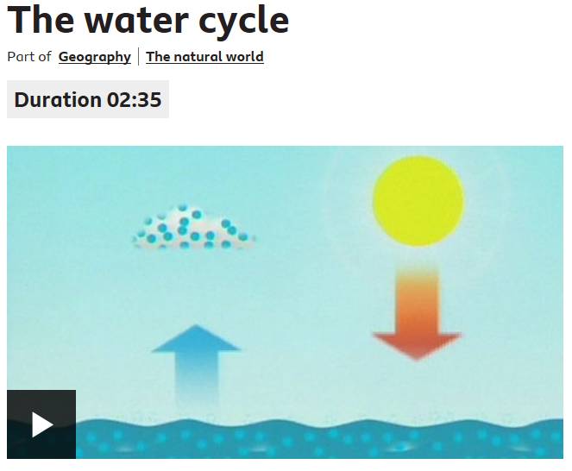
- Please run through the powerpoint and follow the instructions. | 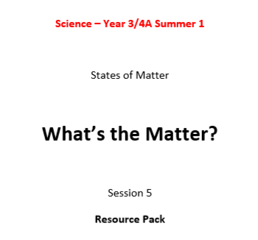
- Enjoy learning and singing along to the Water Cycle Song! You can find the lyrics at the end of the above resource !
- Challenge!
Can you use the vocabulary above to explain the processes water goes through during this cycle? Use you labelled diagram from task 2 to help you.

