Class 7 Science Year 3 and Year 4.
Wb 04.05.20
Please download and follow the instructions if you can. If not, please read through the powerpoint and view the link to the BBC website – this could lead into a discussion about.
Vocabulary:
Solid, liquid, gas, change, state, bromine, ice, freeze, melt, heat, energy, solidify, vapour, evaporation and condensation.
Instructions:
- Please follow the link:  https://www.bbc.co.uk/bitesize/topics/zkgg87h/articles/zydxmnb#ztcjwxs | 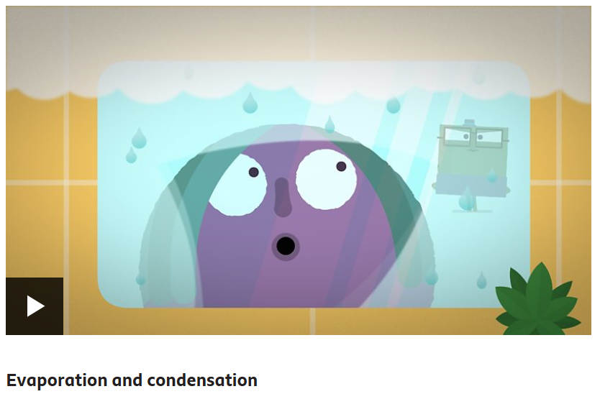
- Please run through the powerpoint and follow the instructions. | 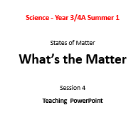
- Challenge!
Can you explain the part played by evaporation and condensation in the water cycle? Can you explain what happens to the rate of evaporation with temperature?

