Class 7 Science Year 3 and Year 4.
Wb 27.04.20
This week it’s a game! Please download and follow the instructions if you can. If not, please read through the powerpoint and view the link to the BBC website – this could lead into a discussion.
Vocabulary:
Solid, liquid, gas, change, state, bromine, ice, freeze, melt, heat, energy, solidify, vapour.
Instructions:
- Please read through. | 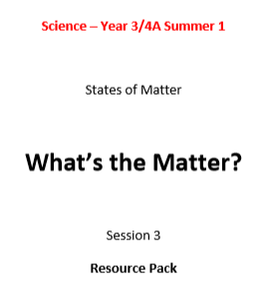
- Please follow the link:  https://www.bbc.co.uk/bitesize/clips/zpbvr82 | 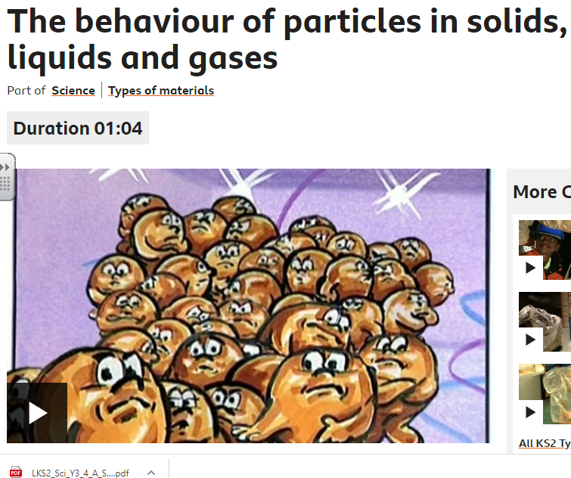
- Challenge!
Can you explain what you found out, using the vocabulary above? This could be spoken, written or even both!

