Class 7 Science Year 3 and Year 4. Wb 20.04.20
Welcome to your new topic: States of Matter! You will be investigating gases and smells (!) – what they are and where they come from. Enjoy…
Vocabulary:
States of matter, material, solid, liquid, gas, natural, manmade, classify, molecule, atom, bonds, air, oxygen, nitrogen, carbon dioxide, argon, molecules.
Instructions:
- Firstly, run through the Challenge PowerPoint and complete the activities. | 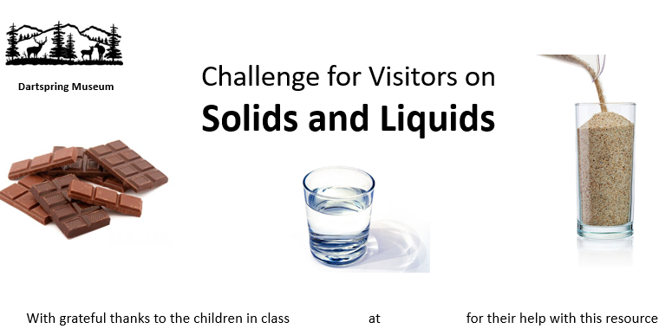
- Have a look at how different gases are used:  https://www.bbc.co.uk/bitesize/clips/zmbygk7  How many different gases did you spot? Make a list. | 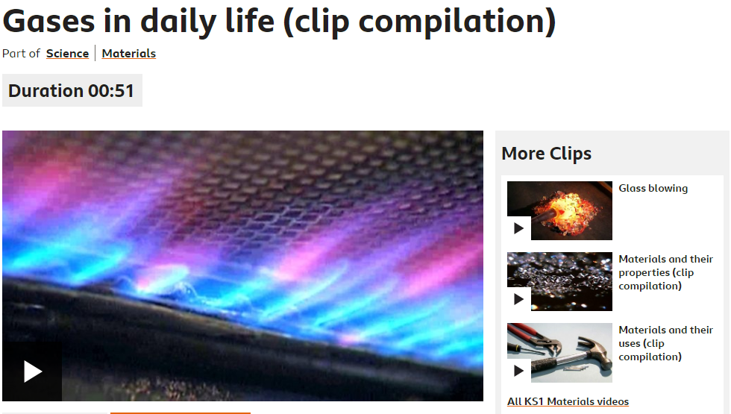
- Run through the Teaching PowerPoint and complete the activities. | 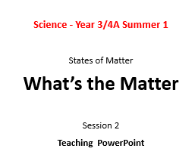
- Use the resource pack to select one or more activities to investigate: choose depending on what you may have available at home. | 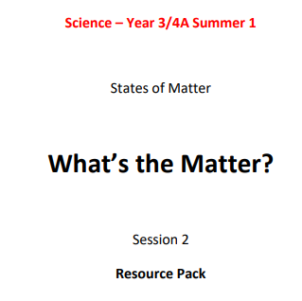
- Write a set of simple instructions for the visitors to follow, explaining what your activity teaches people about gases. Use illustrations and labelled diagrams where necessary. | - Firstly, …  - Secondly, ...  - Thirdly, …  Etc…
- What conclusions can you make?  - Why are smells stronger nearer to the items?  - Why do balloons inflate?  - Why do bottles crush with their caps off, but not when on?  - Why can you move a feather by fanning it? | 

