Class 7 Science Year 3 and Year 4.
Wb 13.04.20
Welcome to your new topic: States of Matter! You will be investigating materials to decide if they are solids, liquids or gases and what it is which makes them so. Enjoy…
Vocabulary:
States of matter, material, solid, liquid, gas, natural, manmade, classify, molecule, atom, bonds
Instructions:
- Explore a number of different objects and decide if they are solid or a liquid. These could be objects around the home or garden, or indeed the air. Slime and jelly pose interesting dilemmas! | 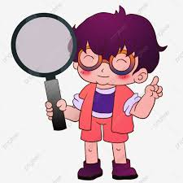
- Record your findings on the classification sheet provided. | 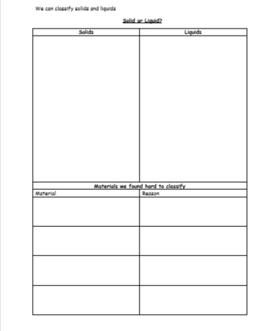
- Can you describe the different properties of materials? Look at the sheet called ‘Describing the properties of solids and liquids’. Can you say what makes these objects a solid or a liquid? Are some had to classify? Can you explain why they are? | 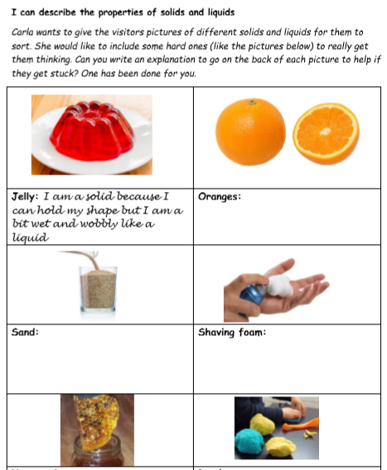
- Check your theories with:  - Powerpoint called What’s the Matter?’  - https://www.bbc.co.uk/bitesize/topics/zkgg87h  Can you conclude by saying why liquids behave differently than solids? In what ways are liquids different, and why? | 

