L.O.To understand the Trimurti of the Hindu religion.
First match and draw a line to the Hindu God’s names to the picture, then match the God to their role.

Vishnu Shiva Brahma

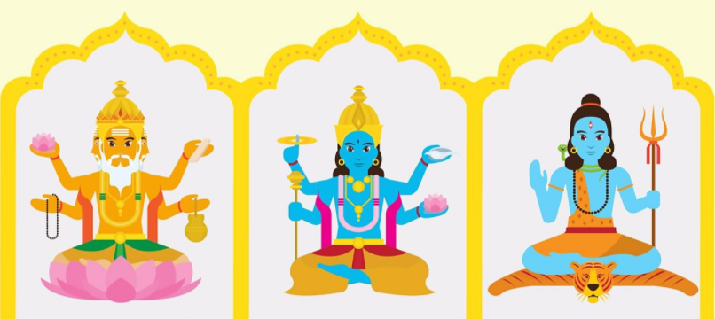

The god of creation.
The god responsible for preserving and protecting the universe.

The god of destruction. His role is to destroy the universe in order to re-create it.

How do the Gods look?
Brahma- _______________________________________________
_____________________________________________________________
_____________________________________________________________
_____________________________________________________________

Vishna-__________________________________________________
_____________________________________________________________
_____________________________________________________________
_____________________________________________________________

Shiva-____________________________________________________
_____________________________________________________________
_____________________________________________________________
_____________________________________________________________

