Class 3 – Reading and Writing (week beginning 4.5.20)

Each week I will set some phonics, reading and spelling activities to be completed/practiced daily. I will also set daily writing activities and a weekly comprehension activity.

Phonics
There will be daily Read Write Inc. phonics sessions that you can access on the following link: https://www.youtube.com/channel/UCo7fbLgY2oA_cFCIg9GdxtQ .
If you are unsure what set sounds your child is working at, please send me a message via the class dojo app. Please also encourage your child to practice spelling some of the words with the sound they have been taught. I would encourage your child to try and watch these sessions everyday.
Set 1 sounds: 9.30am
Set 2 sounds: 10.00am
Set 3 sounds: 10.30am

Reading
There are some RWInc. eBooks which your child can access and read online by following the link:
https://www.oxfordowl.co.uk/for-home/find-a-book/library-page/
Your child will be familiar with the style of these books.
Follow the link and scroll to levels > Read Write Inc level > select colour your child is working at.
Most children know what colour group they are in however, if you are unsure please send me a message via the class dojo app.
Alternatively, your child may like to choose a book they have at home to read to you. I would encourage your child to continue reading daily.

Spellings
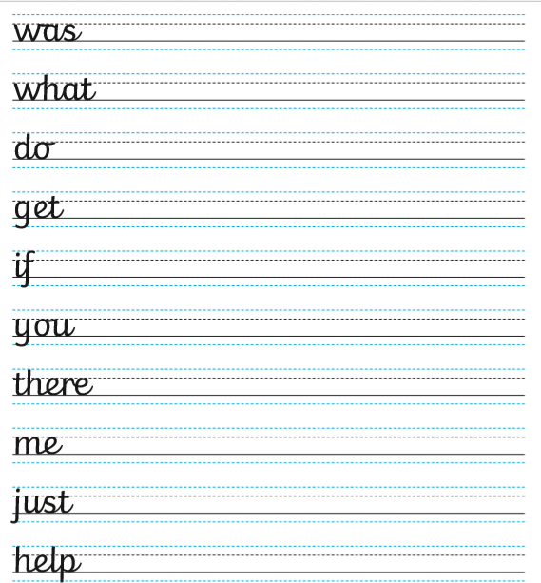
Practice spelling this weeks’ tricky words daily.

Writing
Day 1 – No Thank You!
Follow the PDF link saved on the school website, and follow the steps. There is a writing activity followed by other fun activities that you can complete if you wish.
Today’s story can be found on the school website under ‘Day 1 read- No Thank You!’

Day 2- No Thank You! (continued)
Follow the PDF link saved on the school website, and follow the steps. There is a writing activity followed by other fun activities that you can complete if you wish.
Today’s story can be found on the school website under ‘Day 1 read- No Thank You!’

Day 3- No Thank You! (Final read)
Follow the PDF link saved on the school website, and follow the steps. There is a writing activity followed by other fun activities that you can complete if you wish.
Today’s story can be found on the school website under ‘Day 1 read- No Thank You!’

Day 4- Five Little Senses
Follow the PDF link saved on the school website, and follow the steps. There is a writing activity followed by other fun activities that you can complete if you wish.

Day 5- First Dog on the Moon
Follow the PDF link saved on the school website, and follow the steps. There is a writing activity followed by other fun activities that you can complete if you wish.

Weekly Comprehension- The Three Billy Goats Gruff
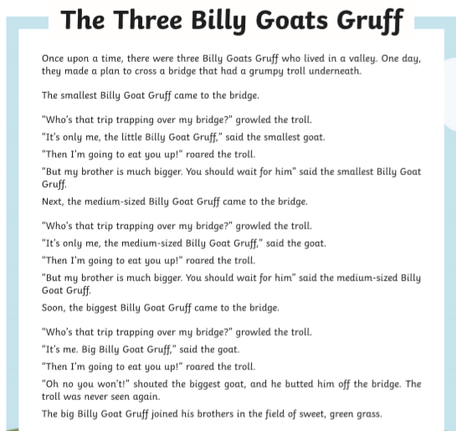
Read the passage below and then answer the questions.



