Class 6 – Maths
Week Beginning 29th June 2020

This week we are continuing to use the videos on the White Rose Maths website for our maths. If you go to the website: https://whiterosemaths.com/homelearning/year-3/ there is a lesson for each day. This week we are onto the Summer Term Week 10 lessons which focus on shape and time. Each day there is a video to watch and then the worksheet to go with it is on the school website. The sheet doesn’t need to be printed, you can just write the answers into your book. Once you have completed the sheet there is an answer sheet so you can check your answers.
Work through Summer Term – Week 10 lessons:
Lesson 1 – Draw accurately
Lesson 2 – Recognise and describe 2D shapes
Lesson 3 – Recognise and describe 3D shapes
Lesson 4 – Telling the time to 5 minutes
Lesson 5 – Friday maths challenge

We are also going to continue the 5-a-Day Challenge. For this go to the website:
https://corbettmathsprimary.com/5-a-day/
Each day there is a sheet with 5 daily challenges on (a bit like the fluent in 5 that we did in class).
Aim to complete the Bronze Challenge each day, if you find this easy do the Silver Challenge instead. The challenges for this week are:
229th June
30th June
1st July
2nd July
3rd July

I have loved seeing what you have been doing. Please keep sending me messages and photos on the class dojo app. I can also answer any questions you may have on there.

Mrs Meade’s Weekly Challenge
I have loved seeing people solving my weekly challenge again – thank you to everyone who has sent photos. Here is how I worked out the problem.
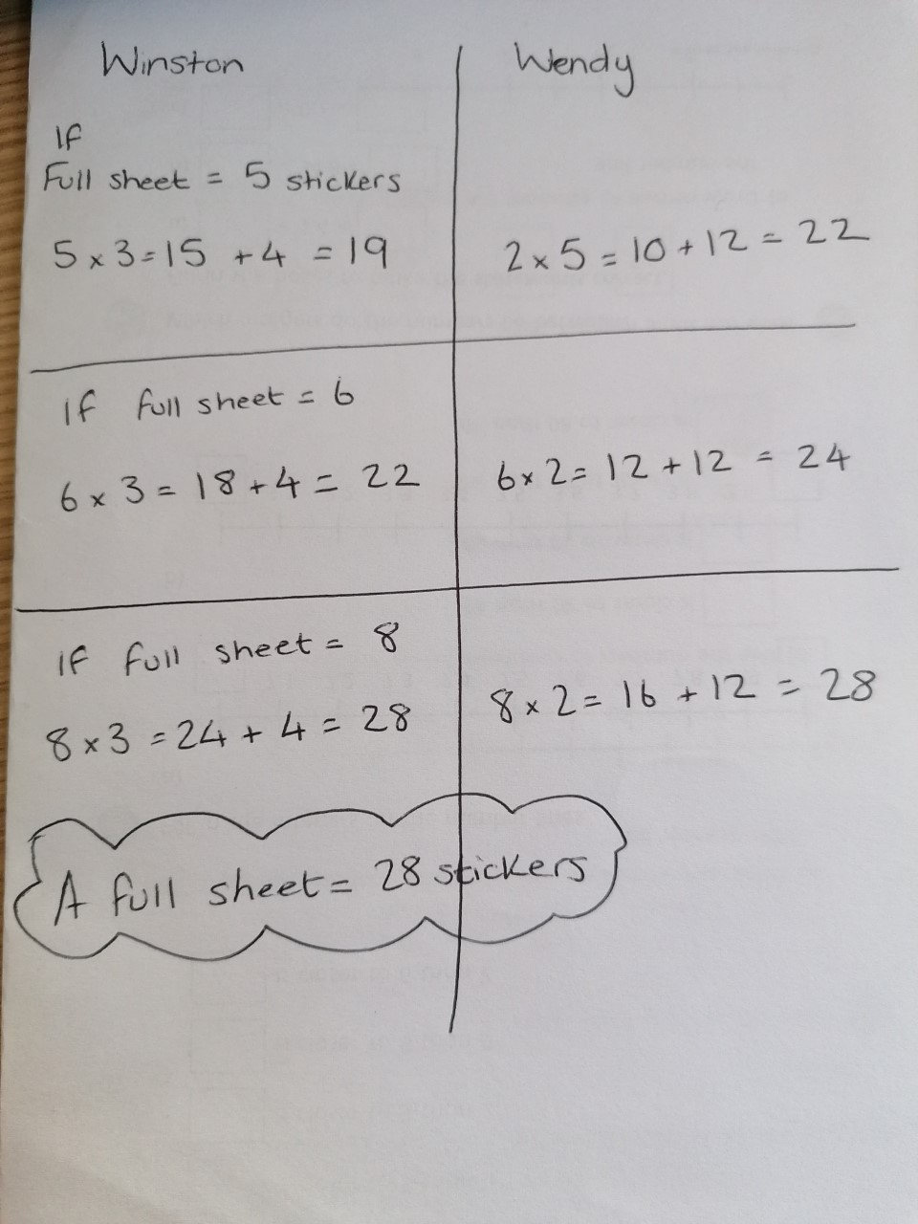
I am going to send the weekly challenges and solutions over the Dojo App from now on

