Class 6 – Maths
Week Beginning 22nd June 2020

This week we are back to using the videos on the White Rose Maths website for our maths. If you go to the website: https://whiterosemaths.com/homelearning/year-3/ there is a lesson for each day. This week we are onto the Summer Term Week 9 lessons which focus on angles and lines. Each day there is a video to watch and then the worksheet to go with it is on the school website. The sheet doesn’t need to be printed, you can just write the answers into your book. Once you have completed the sheet there is an answer sheet so you can check your answers.
Work through Summer Term – Week 9 lessons:
Lesson 1 – Right angles in shapes
Lesson 2 – Compare angles
Lesson 3 – Horizontal and vertical
Lesson 4 – Parallel and perpendicular lines
Lesson 5 – Friday maths challenge

We are also going to continue the 5-a-Day Challenge. For this go to the website:
https://corbettmathsprimary.com/5-a-day/
Each day there is a sheet with 5 daily challenges on (a bit like the fluent in 5 that we did in class).
Aim to complete the Bronze Challenge each day, if you find this easy do the Silver Challenge instead. The challenges for this week are:
22nd June
23rd June
24th June
25th June
26th June

I have loved seeing what you have been doing. Please keep sending me messages and photos on the class dojo app. I can also answer any questions you may have on there.

Mrs Meade’s Weekly Challenge
I have loved seeing people solving my weekly challenge again – thank you to everyone who has sent photos. Here is how I worked out the problem.
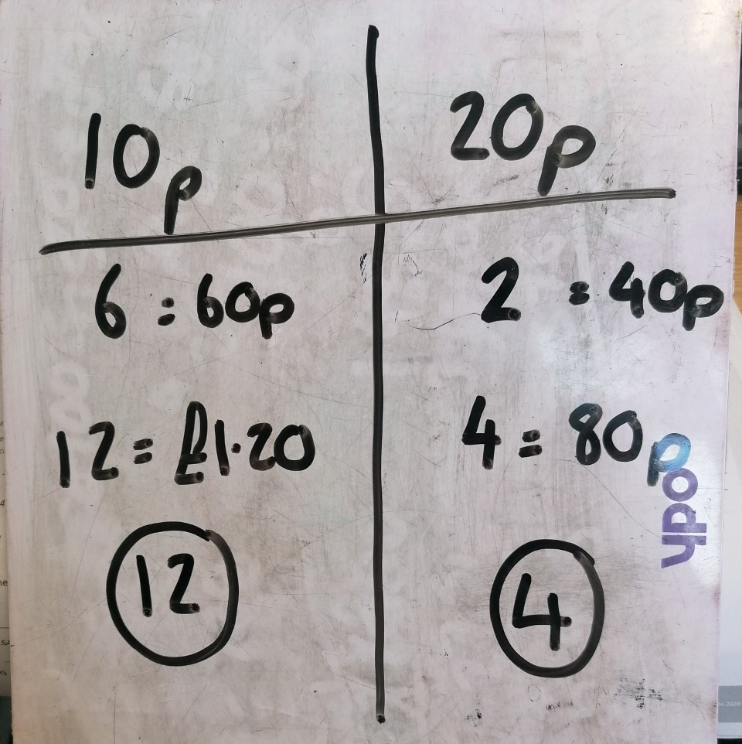

Here is this week’s challenge, I will show you my solution next week. Remember to send me your answers


