Class 6 - Maths
Week Beginning 8th June 2020

We are continuing to use the White Rose Maths websites for our maths however we have already covered the fractions work that they have put on this week. Instead, we will be doing the alternative lessons which cover length. The daily learning video is available at: https://whiterosemaths.com/homelearning/year-3/
The worksheets to go with the lessons are in separate documents on the school website. The sheet doesn’t need to be printed, you can just write the answers into your book.
Work through Summer Term – Week 7 alternative lessons:
Lesson 1 – Measure length
Lesson 2 – Equivalent lengths (m and cm)
Lesson 3 – Equivalent lengths (mm and cm)
Lesson 4 – Compare lengths
Lesson 5 – Friday maths challenge

We are also going to continue the 5-a-Day Challenge. For this go to the website:
https://corbettmathsprimary.com/5-a-day/
Each day there is a sheet with 5 daily challenges on (a bit like the fluent in 5 that we did in class).
Aim to complete the Bronze Challenge each day, if you find this easy do the Silver Challenge instead. The challenges for this week are:
8th June
9th June
10th June
11th June
12th June

I have loved seeing what you have been doing. Please keep sending me messages and photos on the class dojo app. I can also answer any questions you may have on there.

Mrs Meade’s Weekly Challenge
I am still loving seeing people solving my weekly challenge – thank you to everyone who has sent photos. Here is how Bethany E completed last week’s challenge.
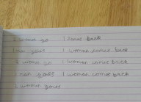

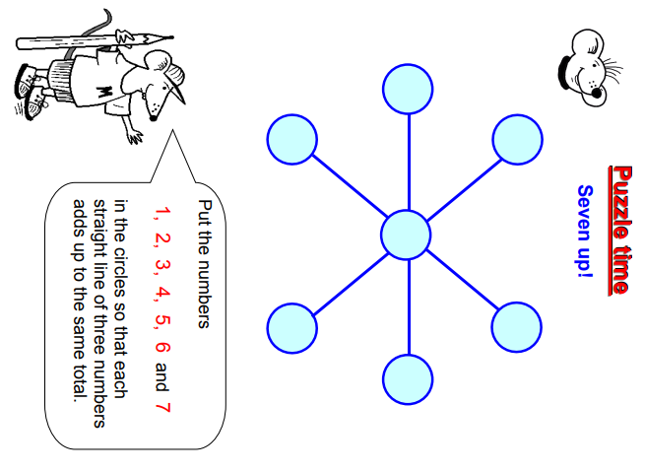
Here is this week’s challenge, I will show you the solution next week. Remember to send me your answers

