Class 6 – Maths
Week Beginning 25th May 2020

This week we are recapping on statistics and money as the White Rose daily lessons are taking a break. For each day there is a worksheet and answers. The sheet doesn’t need to be printed, you can just write the answers into your book. If you need any help feel free to message me on the dojo app.
Monday – Pictograms
Tuesday – Bar charts
Wednesday – Tables
Thursday – Pounds and pence
Friday – Convert pounds and pence

We are also going to continue the 5-a-Day Challenge. For this go to the website:
https://corbettmathsprimary.com/5-a-day/
Each day there is a sheet with 5 daily challenges on (a bit like the fluent in 5 that we did in class).
Aim to complete the Bronze Challenge each day, if you find this easy do the Silver Challenge instead. The challenges for this week are:
25th May
26th May
27th May
28th May
29th May

I have loved seeing what you have been doing. Please keep sending me messages and photos on the class dojo app. I can also answer any questions you may have on there.

Mrs Meade’s Weekly Challenge
I am still loving seeing people solving my weekly challenge – thank you to everyone who has sent photos. Here is how I completed last week’s challenge.

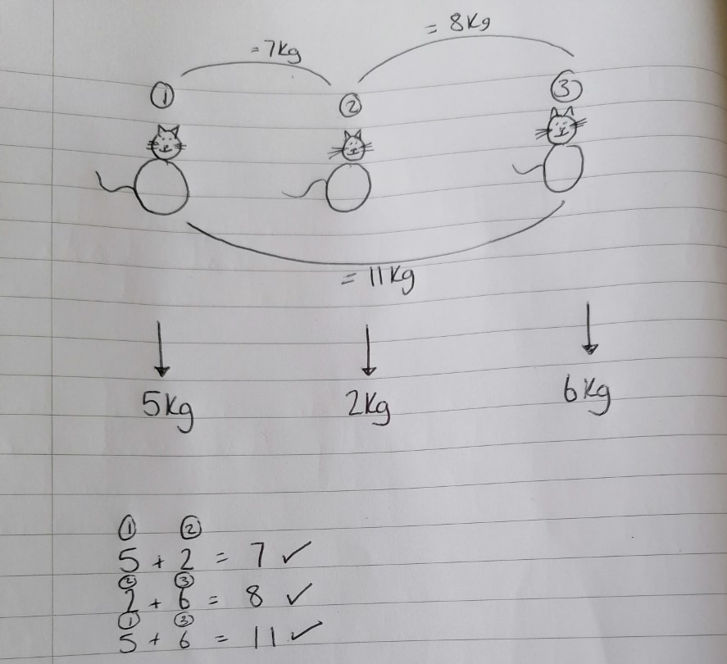

Here is this week’s challenge, I will show you my solution next week. Remember to send me your answers



