Class 6 – Maths
Week Beginning 11th May 2020

We are continuing to use the White Rose Maths and BBC Bitesize websites for our maths. The daily learning video is available at: https://whiterosemaths.com/homelearning/year-3/ and from there you will find the link to that day’s BBC Bitesize page for more information and even more lesson content. The worksheets to go with the lessons are in separate documents on the school website, as are the answers. The sheet doesn’t need to be printed, you can just write the answers into your book.
Work through Summer Term – Week 3 lessons:
Lesson 1 – Multiply and divide by 4 and 8
Lesson 2 – Multiply 2 digit by 1 digit numbers
Lesson 3 – Divide a 2 digit number by a 1 digit number
Lesson 4 – Scaling
Lesson 5 – Friday maths challenge

We are also going to continue the 5-a-Day Challenge. For this go to the website:
https://corbettmathsprimary.com/5-a-day/
Each day there is a sheet with 5 daily challenges on (a bit like the fluent in 5 that we did in class).
Aim to complete the Bronze Challenge each day, if you find this easy do the Silver Challenge instead. The challenges for this week are:
11th May
12th May
13th May
14th May
15th May

I have loved seeing what you have been doing. Please keep sending me messages and photos on the class dojo app. I can also answer any questions you may have on there.

Mrs Meade’s Weekly Challenge
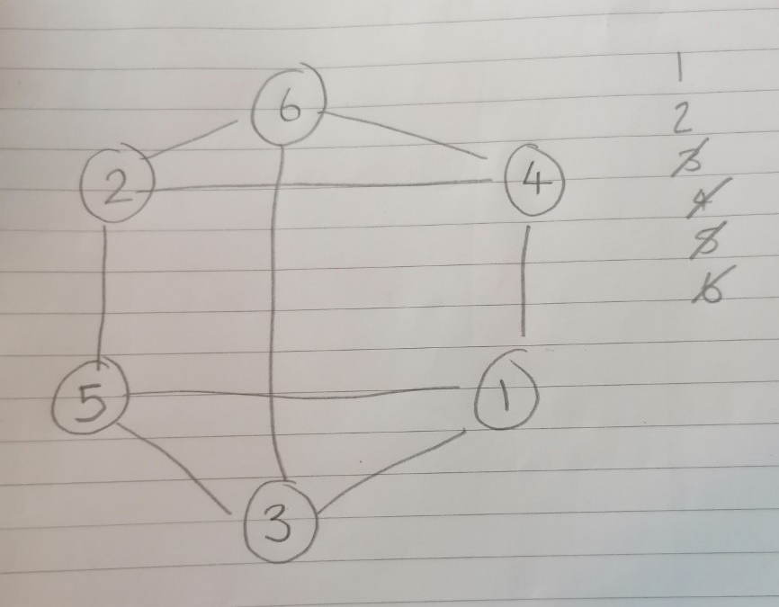
I am still loving seeing people solving my weekly challenge – thank you to everyone who has sent photos. Here is how I completed last week’s challenge. Did you do it in a different way?

Here is this week’s challenge, I will show you my solution next week. Remember to send me your answers


