Class 6 – Maths
Week Beginning 4th May 2020

We are continuing to use the White Rose Maths website for our maths, however they have now joined with BBC Bitesize so it has changed a little bit. There is still a daily learning video on the website: https://whiterosemaths.com/homelearning/year-3/ but there will also be a link to that day’s BBC Bitesize page for more information and even more lesson content. The worksheets to go with the lessons are now in separate documents on the school website, as are the answers. The sheet doesn’t need to be printed, you can just write the answers into your book.
Work through Summer Term – Week 3 lessons:
Lesson 1 – Convert pounds and pence
Lesson 2 – Adding money
Lesson 3 – Subtracting money
Lesson 4 – Multiply and divide by 3
Lesson 5 – Friday maths challenge

We are also going to continue the 5-a-Day Challenge. For this go to the website:
https://corbettmathsprimary.com/5-a-day/
Each day there is a sheet with 5 daily challenges on (a bit like the fluent in 5 that we did in class).
Aim to complete the Bronze Challenge each day, if you find this easy do the Silver Challenge instead. The challenges for this week are:
4th May
5th May
6th May
7th May
8th May

I have loved seeing what you have been doing. Please keep sending me messages and photos on the class dojo app. I can also answer any questions you may have on there.

Mrs Meade’s Weekly Challenge
I have loved seeing people solving my weekly challenge again – thank you to everyone who has sent photos. I enjoyed last week’s challenge – here are the 7 solutions I found.

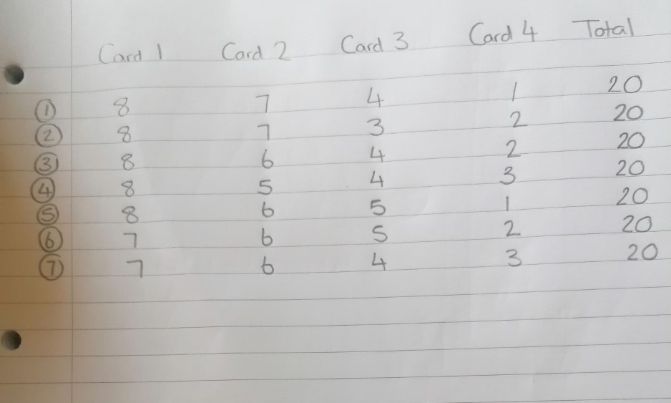

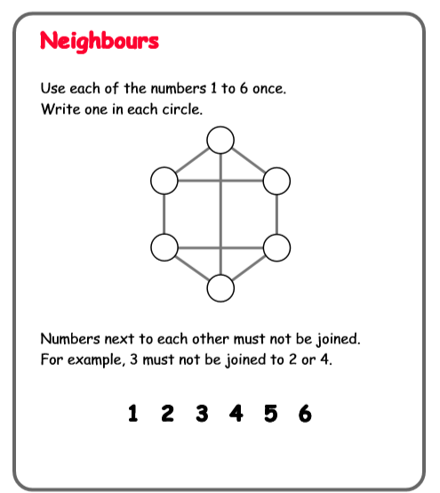
Here is this week’s challenge, I will show you my solution next week. Remember to send me your answers

