Class 3 – Reading and Writing (week beginning 13.4.20)

Each week I will set some phonics, reading and spelling activities to be completed/practiced daily. I will also set daily writing activities and a weekly comprehension activity.

Phonics
There will be daily Read Write Inc. phonics sessions that you can access on the following link: https://www.youtube.com/channel/UCo7fbLgY2oA_cFCIg9GdxtQ .
If you are unsure what set sounds your child is working at, please send me a message via the class dojo app. Please also encourage your child to practice spelling some of the words with the sound they have been taught. I would encourage your child to try and watch these sessions everyday.
Set 1 sounds: 9.30am
Set 2 sounds: 10.00am
Set 3 sounds: 10.30am

Reading
There are some RWInc. eBooks which your child can access and read online by following the link:
https://www.oxfordowl.co.uk/for-home/find-a-book/library-page/
Your child will be familiar with the style of these books.
Follow the link and scroll to levels > Read Write Inc level > select colour your child is working at.
Most children know what colour group they are in however, if you are unsure please send me a message via the class dojo app.
Alternatively, your child may like to choose a book they have at home to read to you. I would encourage your child to continue reading daily.

Spellings
Practice spelling this weeks tricky words daily.

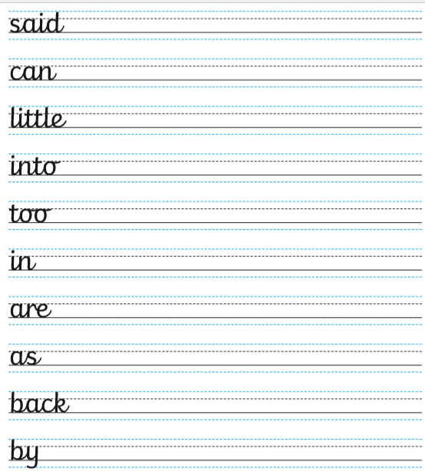

Writing
Lesson 1 – Dear Postman
Follow the link, and follow the steps. There is a writing activity followed by other fun activities that you can complete if you wish.
file:///C:/Users/stfullerton/AppData/Local/Temp/Temp1_English_Y1_Week_2%20(1).zip/Y1%20Day%206.pdf
Today’s story can be found on the link below:
file:///C:/Users/stfullerton/AppData/Local/Temp/Temp1_English_Y1_Week_2%20(1).zip/dear_postman_v2.pdf

Lesson 2- Boris and Sid are bad!
Follow the link, and follow the steps. There is a writing activity followed by other fun activities that you can complete if you wish.
file:///C:/Users/stfullerton/AppData/Local/Temp/Temp1_English_Y1_Week_2%20(1).zip/Y1%20Day%207.pdf
Today’s story can be found on the link below:
file:///C:/Users/stfullerton/AppData/Local/Temp/Temp1_English_Y1_Week_2%20(1).zip/GR_Boris_and_Sid_are_bad.pdf

Lesson 3- Instructions
Follow the link, and follow the steps. There is a writing activity followed by other fun activities that you can complete if you wish.
file:///C:/Users/stfullerton/AppData/Local/Temp/Temp1_English_Y1_Week_2%20(1).zip/Y1%20Day%208.pdf

Lesson 4- The Owl and the moon
Follow the link, and follow the steps. There is a writing activity followed by other fun activities that you can complete if you wish.
file:///C:/Users/stfullerton/AppData/Local/Temp/Temp1_English_Y1_Week_2%20(1).zip/Y1%20Day%209.pdf
The link for today’s story is below:
file:///C:/Users/stfullerton/AppData/Local/Temp/Temp1_English_Y1_Week_2%20(1).zip/GR_The_owl_and_the_moon.pdf

Lesson 5- Nocturnal animals
Follow the link, and follow the steps. There is a writing activity followed by other fun activities that you can complete if you wish.
file:///C:/Users/stfullerton/AppData/Local/Temp/Temp1_English_Y1_Week_2%20(1).zip/Y1%20Day%2010.pdf

Weekly Comprehension- Goldilocks and the Three bears
Read the passage below and then answer the questions.



