Class 6 – Maths
Week Beginning 27th April 2020

We are continuing to use the White Rose Maths website for our maths. If you go to the website: https://whiterosemaths.com/homelearning/year-3/ there is a lesson for each day. This week we are onto the Summer Term Week 2 lessons which continue to build on the fraction work from last three weeks. Each day there is a video to watch which has an activity sheet to go with it. The sheet doesn’t need to be printed, you can just write the answers into your book. Once you have completed the sheet there is an answer sheet so you can check your answers.
Work through Summer Term – Week 2 lessons:
Lesson 1 – Add fractions
Lesson 2 – Subtract fractions
Lesson 3 – Problem solving
Lesson 4 – Problem solving
Lesson 5 – Friday maths challenge

We are also going to continue the 5-a-Day Challenge. For this go to the website:
https://corbettmathsprimary.com/5-a-day/
Each day there is a sheet with 5 daily challenges on (a bit like the fluent in 5 that we did in class).
Aim to complete the Bronze Challenge each day, if you find this easy do the Silver Challenge instead. The challenges for this week are:
27th April
28th April
29th April
30th April
1st May

I have loved seeing what you have been doing. Please keep sending me messages and photos on the class dojo app. I can also answer any questions you may have on there.

Mrs Meade’s Weekly Challenge
I have loved seeing people solving my weekly challenge again – thank you to everyone who has sent photos. I enjoyed last week’s challenge – here are 4 of the solutions that I came up with. Did you find any different ones?

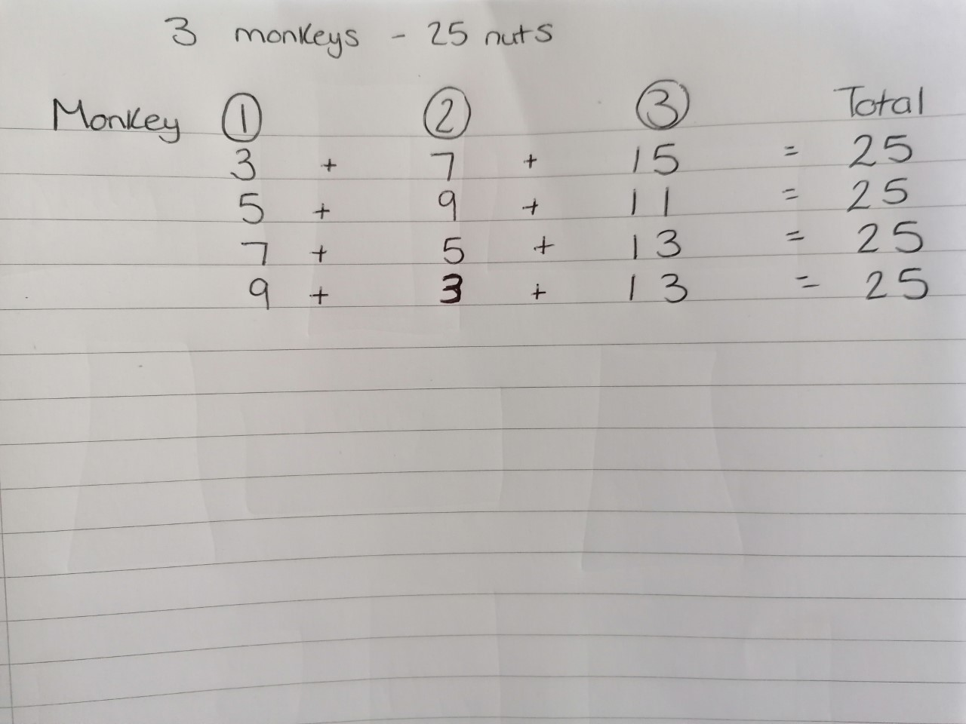

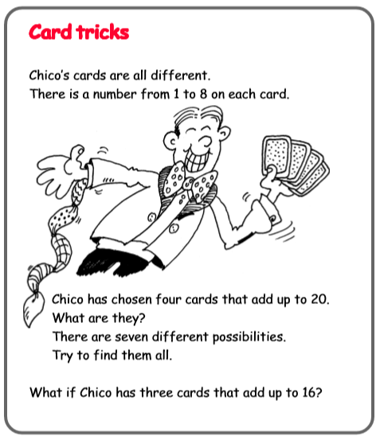
Here is this week’s challenge, I will show you my solution next week. Remember to send me your answers

