Class 6 – Maths
Week Beginning 13th April 2020

We are continuing to use the White Rose Maths website for our maths. If you go to the website: https://whiterosemaths.com/homelearning/year-3/ there is a lesson for each day. This week we are onto the week 2 lessons which build on the fraction work from last week. Each day there is a video to watch which has an activity sheet to go with it. The sheet doesn’t need to be printed, you can just write the answers into your book. Once you have completed the sheet there is an answer sheet so you can check your answers.
Work through Week 2 lessons:
Lesson 1 – Fractions on a number line
Lesson 2 – Fractions of a set of objects (1)
Lesson 3 – Fractions of a set of objects (2)
Lesson 4 – Fractions of a set of objects (3)
Lesson 5 – Equivalent fractions (1)

We are also going to continue the 5-a-Day Challenge. For this go to the website:
https://corbettmathsprimary.com/5-a-day/
Each day there is a sheet with 5 daily challenges on (a bit like the fluent in 5 that we did in class).
Aim to complete the Bronze Challenge each day, if you find this easy do the Silver Challenge instead. The challenges for this week are:
13th April
14th April
15th April
16th April
17th April

I have loved seeing what you have been doing. Please keep sending me messages and photos on the class dojo app. I can also answer any questions you may have on there.

Mrs Meade’s Weekly Challenge
I have loved seeing people solving my weekly challenge again – thank you to everyone who has sent photos. Here is how I worked out the problem – I found 4 different ways of making 23 legs (thank you to Bethany E for giving me the top tip that there has to be an odd number of Tripods).
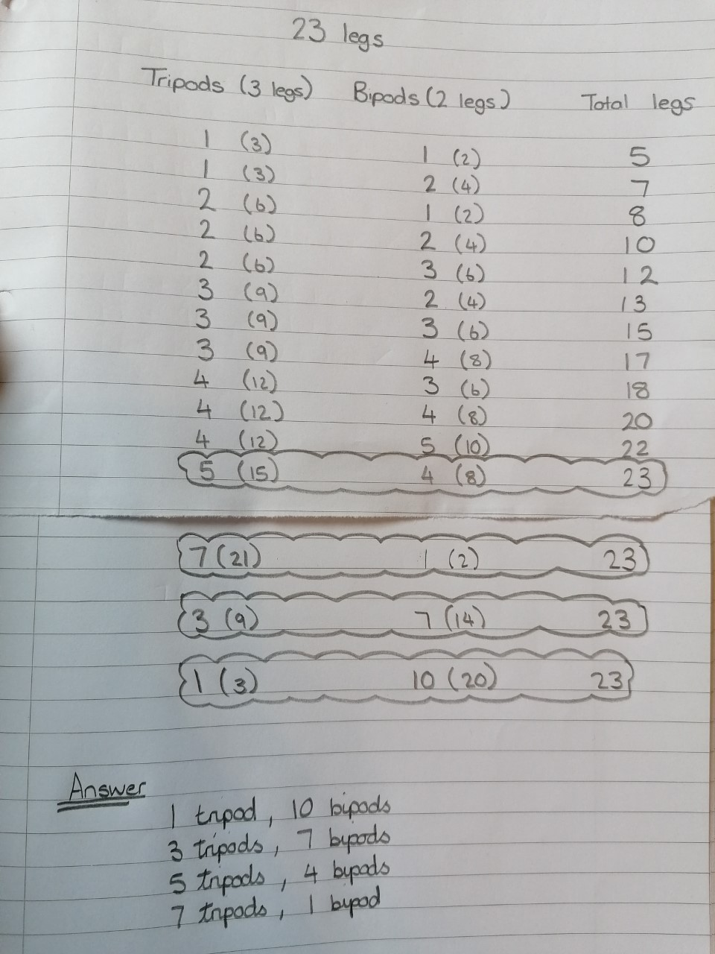

hh

Here is Bethany’s solution – I love how she has used multiplication and division to work out the answer!

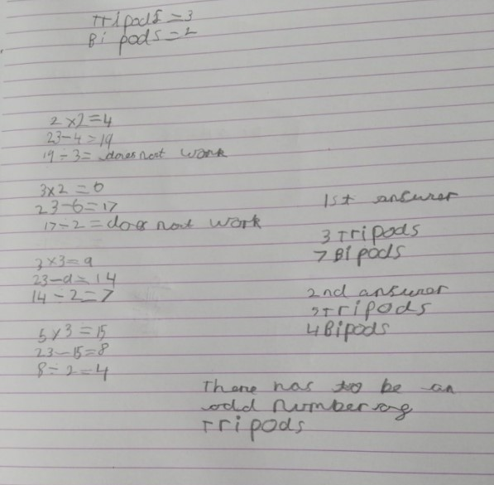

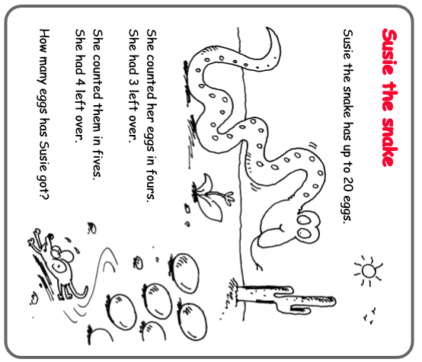
Here is this week’s challenge, I will show you my solution next week. Remember to send me your answers 😊

