Class 6 – Maths
Week Beginning 6th April 2020

We are now going to be using the White Rose Maths website for our maths. If you go to the website: https://whiterosemaths.com/homelearning/year-3/ there is a lesson for each day. We are going to start on the week one lessons which are all about fractions. Each day there is a video to watch which has an activity sheet to go with it. The sheet doesn’t need to be printed, you can just write the answers into your book. Once you have completed the sheet there is an answer sheet so you can check your answers.
Work through Week 1 lessons:
Lesson 1 – Unit and non-unit fractions
Lesson 2 – Making the whole
Lesson 3 – Tenths
Lesson 4 – Count in tenths
Lesson 5 – Tenths as decimals

We are also going to be doing a 5-a-Day Challenge each day. For this go to the website:
https://corbettmathsprimary.com/5-a-day/
Each day there is a sheet with 5 daily challenges on (a bit like the fluent in 5 that we did in class).
Aim to complete the Bronze Challenge each day, if you find this easy do the Silver Challenge instead. The challenges for this week are:
6th April
7th April
8th April
9th April
10th April

I would love to see what you have done, I will be checking the class dojo site every day – you can send photos on there so I can see. I will also send out challenges on the dojo app for you to try.

Mrs Meade’s Weekly Challenge
I have loved seeing people solving my weekly challenge – thank you to everyone who has sent photos. Here is how I worked out the problem – did you get the same answer even if you worked it out a different way?
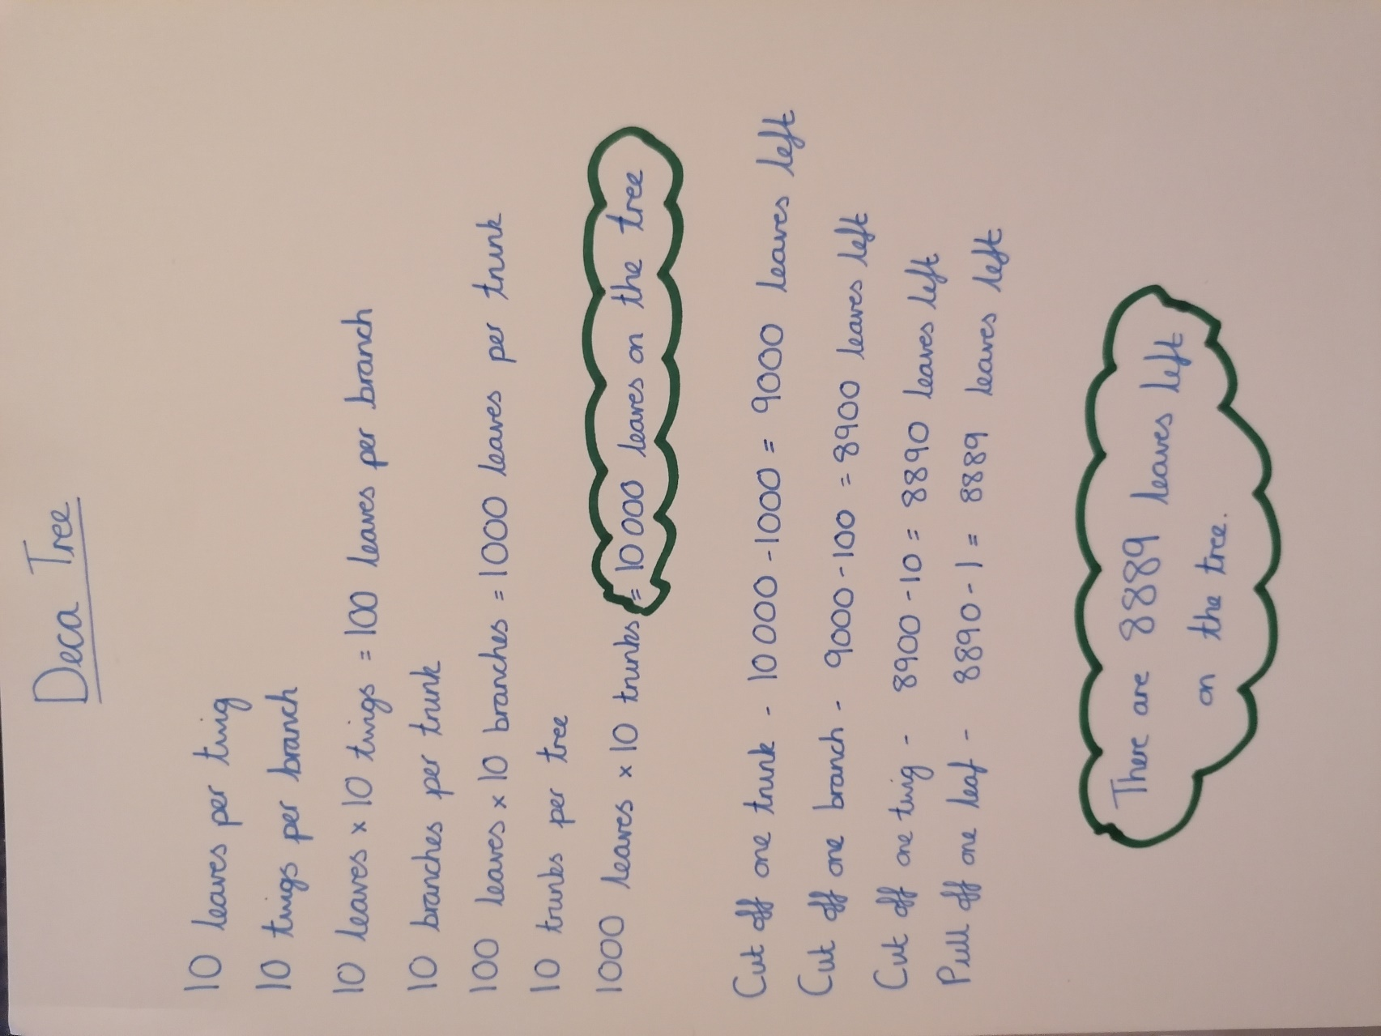
Here is this week’s challenge, I will show you my solution next week. Remember to send me your answers


