Class 7 TOPIC 13/7/20
Geography: Water

Water Pollution

In this lesson you will find out about the causes and effects of water pollution.  - Work your way through the PowerPoint.  - Watch these clips  https://www.bbc.co.uk/teach/class-clips-video/primary-science-what-happens-to-our-sewage/zrmhy9q  https://www.bbc.co.uk/programmes/p0114f7c  - Answer any questions.  - Complete the 3 work sheets:  1. The Unflushables poster  2. Marine Litter Poster  3. Research and report on Marine Pollution | 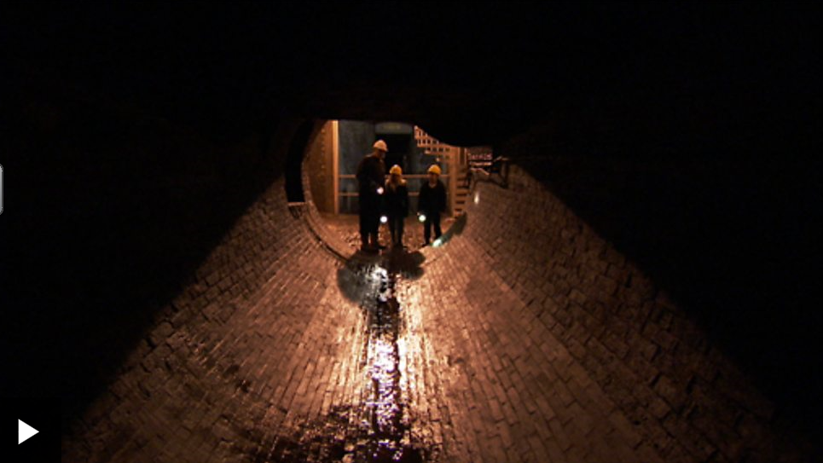
 | 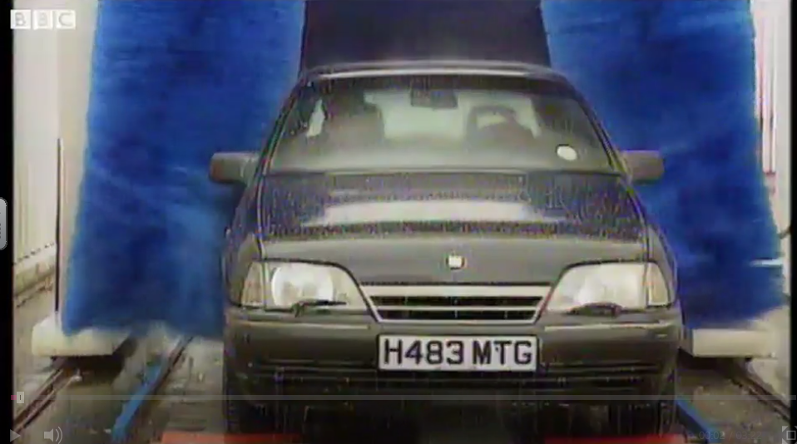

Challenge:
- Create a PowerPoint presentation or leaflet on the causes and effects of water pollution.

