Class 7 Topic: Geography: Water
The Causes and Effects of Flooding
- In this lesson you will find out about the causes and effects of flooding.  •Work your way through the PowerPoint.  •Answer any questions. | 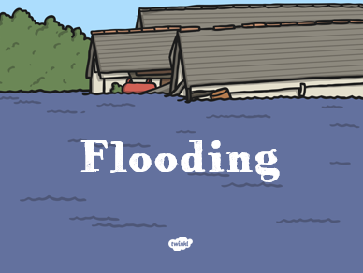
- Read the Flooding in Boscastle sheet.  •Complete the work sheets. | 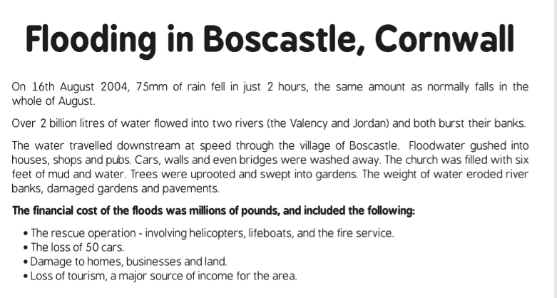
- Carefully look around your home. Complete the Are We Ready? Flood survey.  •What actions would you want to take if a flood alert was triggered for Scarborough? Write down your answer. | 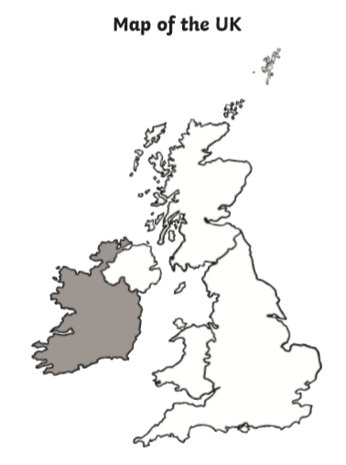
Challenge:
•Use the internet to research the locations of recent flooding in the UK and mark these on a map – what do the areas have in common? What makes an area prone to flooding? The Environment Agency website has details of flood warnings for specific areas, as well as a Post Coded search facility to find out the level of risks in different areas.

•Find out about the impact building developments can have on flooding, for example houses built on flood plains, deforestation or the impact of concrete surfaces in increasing run-off. You could make a poster, leaflet or PowerPoint to display your research.

