Class 7 Topic
WB 29.06.20
Geography: Water Making clouds and rain.

- In this lesson you will find out how clouds and rain are formed.  - Work your way through the PowerPoint.  - Answer any questions. | 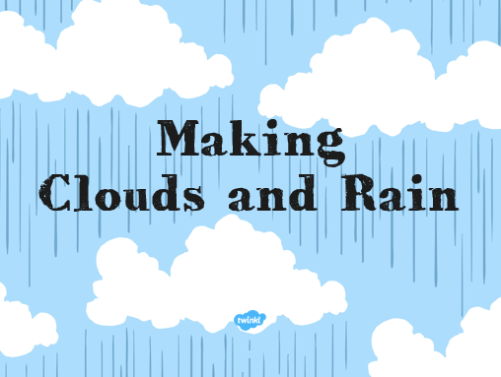
- Complete the work sheets. | 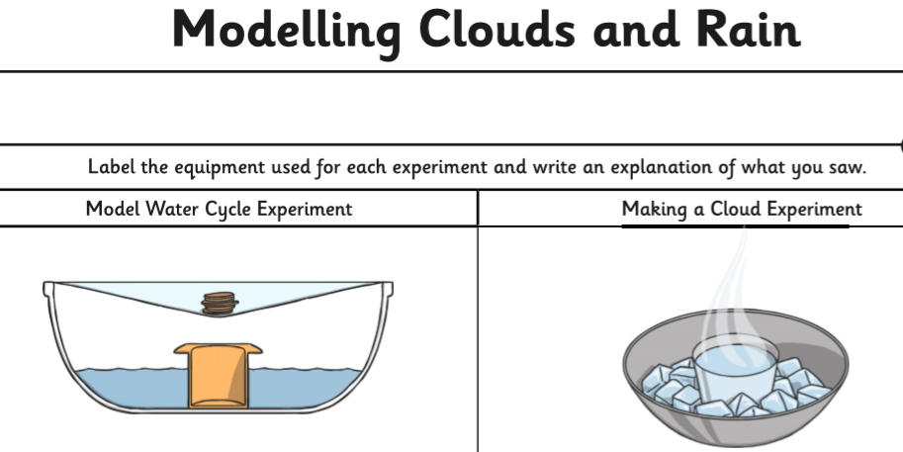
- Have a go at the experiments with your grown up for safety.  - If you don’t have any of the equipment/items for the experiments, please don’t worry or feel that you have to go out and buy anything. You could try to use an alternative that you already have at home.  - There are many poems about clouds, wandering lonely! Explore some cloud poems or write your own! | 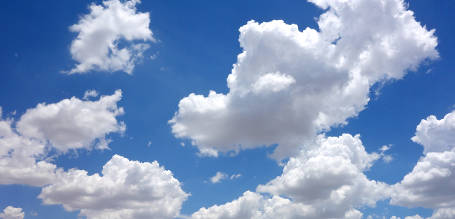
Lesson 2-

