Class 3 – Reading and Writing (week beginning 30.3.20)

Each week I will set some phonics, reading and writing activities.

Activity 1- Phonics
There will be daily Read Write Inc. phonics sessions that you can access on the following link: https://www.youtube.com/channel/UCo7fbLgY2oA_cFCIg9GdxtQ .
If you are unsure what set sounds your child is working at, please send me a message via the class dojo app. Please also encourage your child to practice spelling some of the words with the sound they have been taught.
Set 1 sounds: 9.30am
Set 2 sounds: 10.00am
Set 3 sounds: 10.30am

Activity 2- Reading
There are some RWInc. eBooks which your child can access and read online by following the link:
https://www.oxfordowl.co.uk/for-home/find-a-book/library-page/
Your child will be familiar with the style of these books. Follow the link and scroll to levels>Read Write Inc level> select colour your child is working at. Most children know what colour group they are in however, if you are unsure please send me a message via the class dojo app.
Alternatively, your child may like to choose a book they have at home to read to you.

Activity 3- Writing
Can you write a letter to me, explaining what things you have been getting up to at home?
Remember the different features that you should include when writing a letter (date, Dear…, address etc.) I’ll help you get started:

Barrowcliff School
Ash Grove
Scarborough
YO12 6NJ

26th March 2019

Dear, Miss Fullerton,
This week I have done lots of fun and exciting things. I can’t wait to tell you about it all. On Monday…

From, (your name)

Activity 4- Descriptive writing
Look at the photo of the monster and use the adjectives to help you describe him.
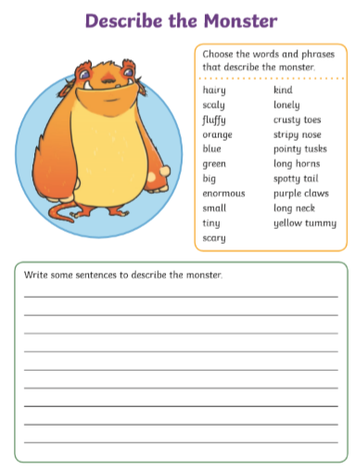

Activity 5- Spellings
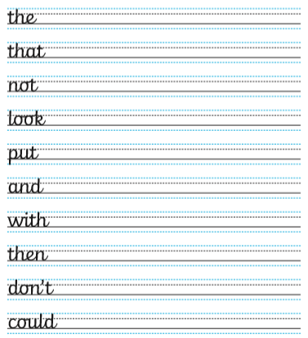
Activity 5- Spellings
Practice spelling this week’s tricky words below.

