Class 7 Topic wb 22.06.20
Geography: The Water Cycle.

- In this lesson you will find out about the The Water Cycle.  Work your way through the PowerPoint.  Answer any questions. | 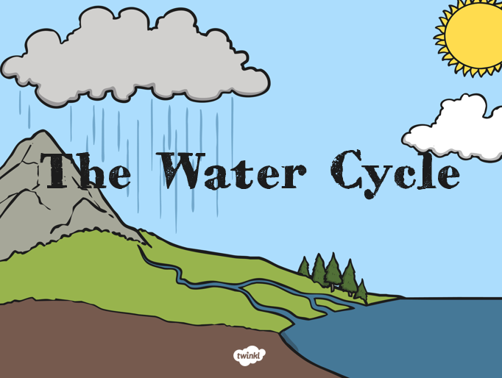
- Complete the work sheet: Label the water cycle process from slide 6. Explain the process to a family member. | 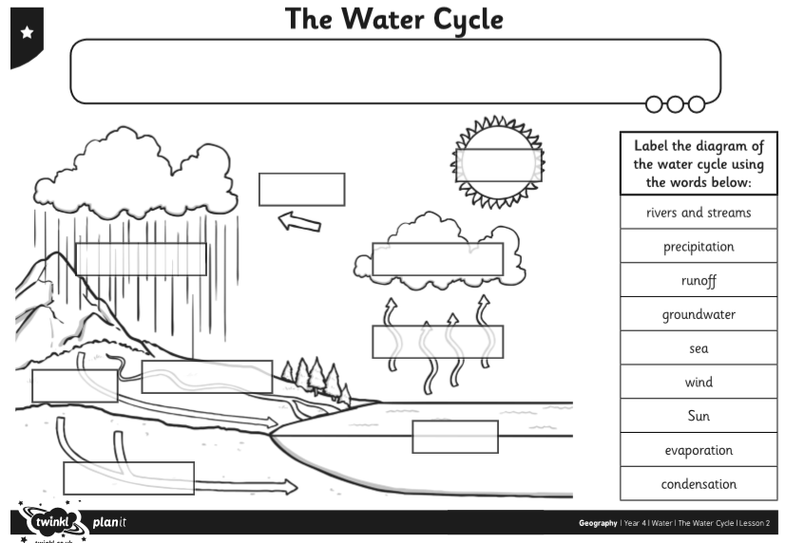
- Create a leaflet explaining what the water cycle process is. You can include pictures and diagrams; draw them yourself, or copy and paste from the internet – not forgetting to label them.  - Complete the word search. | 

