Class 7 Years 3 and 4: Topic. Wb 25.05.20
French: Where in the World?
Lesson 1- United Kingdom  In this lesson you will find out about the United Kingdom and will ask and answer questions.  - Work your way through the PowerPoint. There are sound buttons that will say the words for you in French, for you to copy and repeat. You can play these as many times as you like.  - Complete the work sheets.  - If you find it tricky, just have a go! | 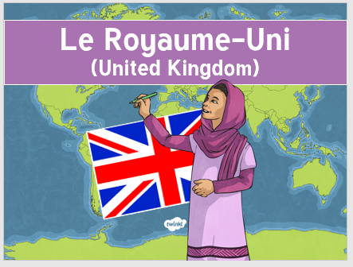
Extra Activities:  - Use dictionaries/online translators to find the names of other capital cities in the world. On a blank world map mark the capital cities and the French way of saying them.  - Draw flags of different countries and write sentences in French to say what the capital city is. | 

