Class 7 Years 3 and 4: Topic. Wb 11.05.20
Where in the World 4 – On The Line.
Background:
In this lesson you will find out about Prime Meridians.
The term ‘meridian’ comes from a Latin word that means ‘midday’. The Sun crosses each meridian halfway between sunrise and sunset. The Prime Meridian is the line of longitude 0°E/W (nought degrees East and West).
Before 1884, different countries based their maps and charts on a 0° longitude line that passed through their own capital city. What problems could that cause? For example, Sailors would need to convert between charts when travelling long distances.
In 1884, the International Meridian Conference chose to make the line at 0° longitude run through the Royal Observatory in Greenwich, England. The conference chose Greenwich (London) as most of the world’s ships used this meridian already.
Instructions:
- Read the PowerPoint presentation carefully and answer any questions. | 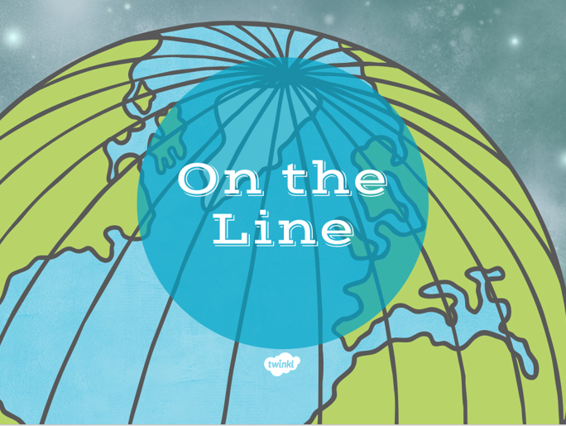
- Complete Worksheet ‘Countries on the line’. | 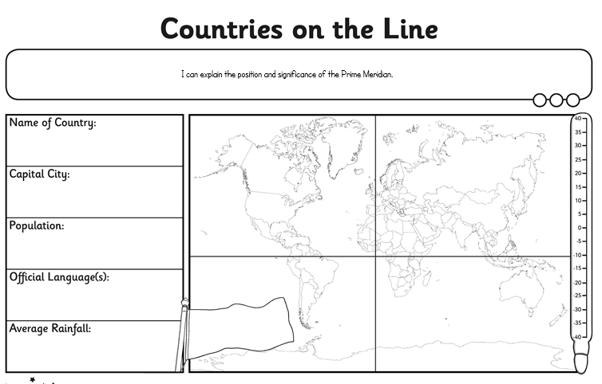
- Choose a country on The Meridian Line and find out the information on the sheet: Locate the county, Country Name, Capital city, Population, Language, Rainfall and Temperature.
- Challenge!  What else can you find out about your chosen country?  What tourist sites could you visit?  How would you get there?  What is the currency? | 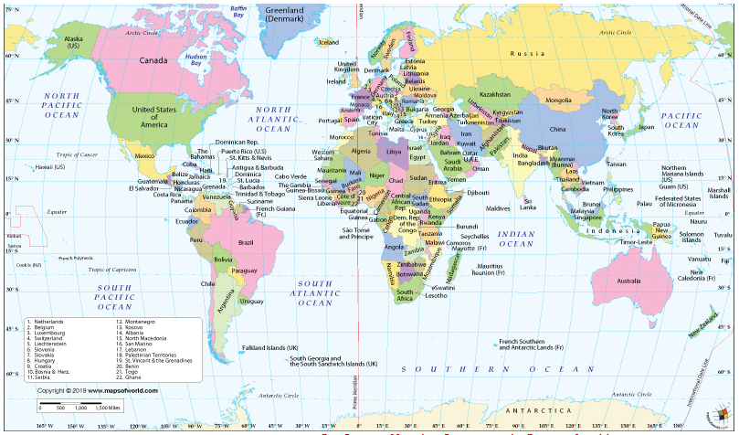

Extra Activities:
• Plan a trip travelling to all the countries that are ‘on the line’ of the Prime Meridian – how could you travel? What would you see?
• Use these interactive maps to look at some of the markers which have been placed to show visitors that they are ‘on the line’, both in the UK and overseas.
http://www.thegreenwichmeridian.org/tgm/articles.php?article=0
• The Royal Observatory in Greenwich is home to some clocks made by clockmaker John Harrison in the 1700s. His clocks helped sailors keep time even on stormy seas. Challenge children to make a water clock or sand timer that will time exactly one minute!

