Art
L.O.To use plants as a creative stimulus.

In our Science topic we have been looking at plants. We have learned what makes them grow, how they reproduce, how they distribute their seeds and the functions of the different parts of the plant. In this lesson, we are going to use flowers/plants or nature to create a work of art.

Andy Goldsworthy is an artist who uses nature for his artwork.

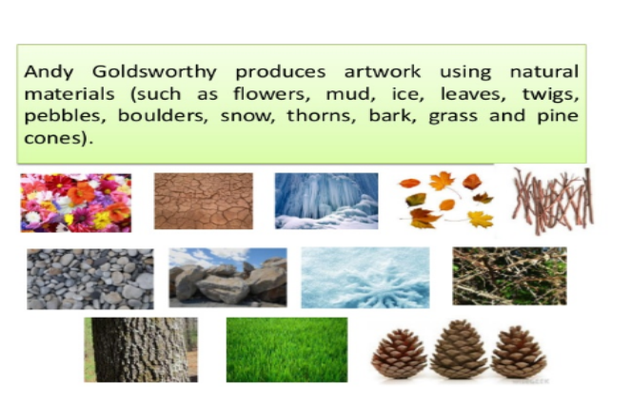
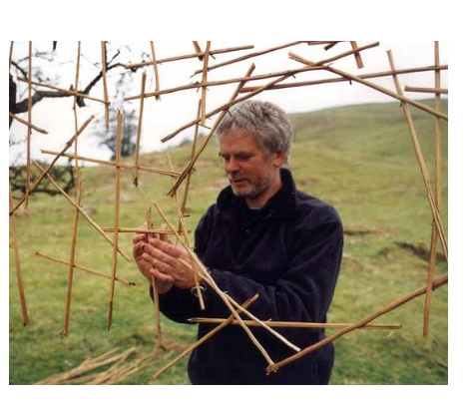

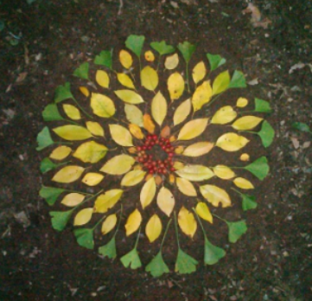
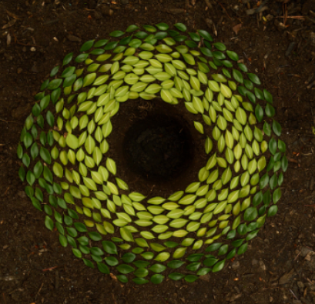
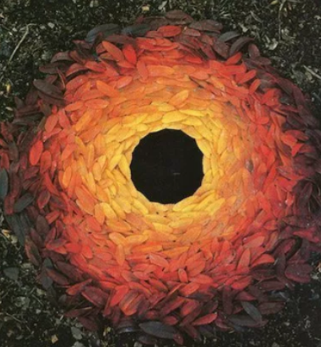
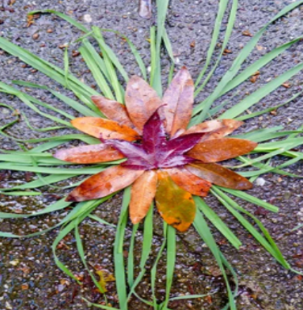
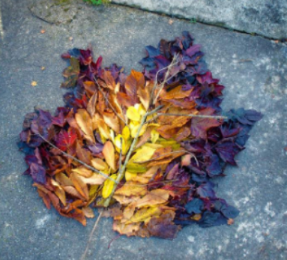

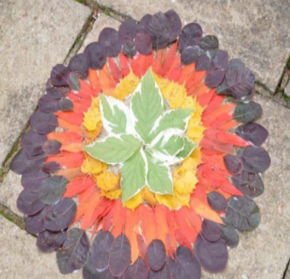
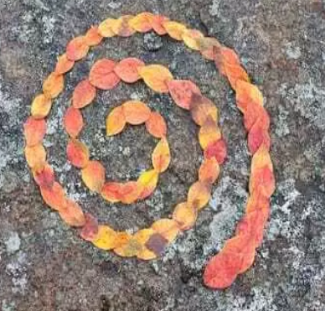
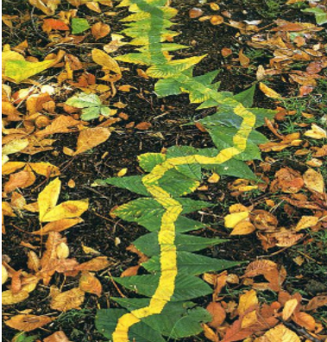

Task: Have a look outside to see what leaves and flowers you can find to include in your artwork. You might get some inspiration from the above pictures to help you. When designing your artwork, think about pattern, colour (shades of different colours as well) and shape. What will you choose as a background? Will it be soil, paving, grass or something else?

Take a photo or draw a picture of your design.

What did you use for inspiration? Did you use one of Andy Goldsworthy for inspiration?

What plants/flowers or other parts of nature did you use?

What did you choose for your background and why?

What could you do to make it a better piece of art?

What part of your work do you like that best?

How do you feel about your artwork?

