Class 7 Years 3 and 4: Topic. Wb 04.05.20
Where in the World 3?
Instructions:
- In this lesson you will find out about different habitats found in the tropics. Please read through the powerpoint and answer any questions. | 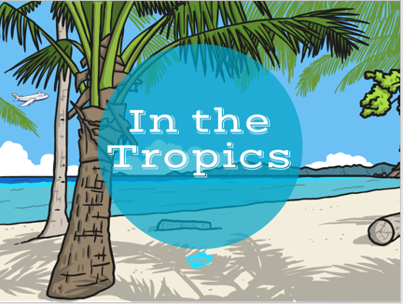
- Describe the similarities and differences between the weather in the UK and the tropics. Note that the climates are very different.
- Select an area of the tropics using the worksheet ‘Tropical Weather Areas Activity Cards’. Research the climate of that area of the tropics, and use the ‘Tropical Weather Report’ Activity Sheet to record your findings. | 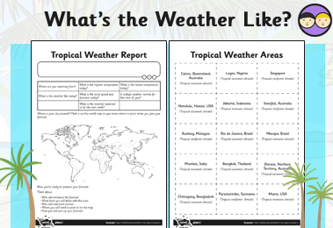
- Use this information to prepare a weather forecast to present to your family.

Extra Activities:
- Create a tropical jungle picture – use a black pen to draw overlapping trunks and branches and jungle animals hiding amongst them. Add detailed patterns and vivid colours to the foreground to help camouflage the animals.
- Plan a visit to a tropical location.
What could you do and see there?
What preparations would you make (for example, packing)?
How would you travel to the tropics and then between locations?

