Class 7 Years 3 and 4: Topic. Wb 27.04.20
Where in the World 2?
Instructions:
- Let’s explore the Earth’s poles - the Arctic Circle and the Antarctic Circle. They begin at 66°N and 66°S respectively.  Please read through the powerpoint and answer any questions. | 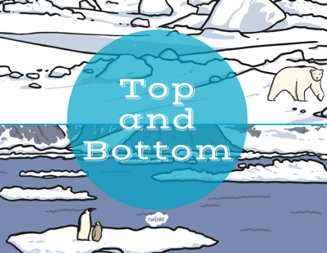
- Explain your answer to ‘Would you rather..’. This can be spoken, written, or even both! | 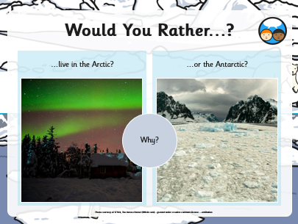
- Please choose the difficulty and then complete the worksheets. | 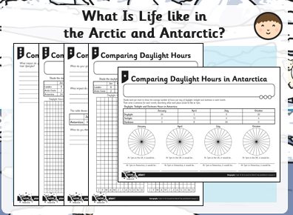

Extra Activities:
- Exploreit: Find out about the intrepid polar explorers who first travelled to the Arctic and Antarctic. What challenges did they face? How did they prepare for their journeys? How do travellers to the Poles prepare today?
- Reliveit: Use this website to find out more about Shackleton’s 1914-1917 expedition to Antarctica. http://shackleton100.com/antarctica/
- Watchit: Watch Ice Age and compare the animals and habitats shown in the film with those found in the polar regions today.

