Class 7 Years 3 and 4: Topic. Wb 20.04.20
Where in the World?
Instructions:
- Read through the PowerPoint on Longitude and Latitude.  Lines Around: Latitude lines run from east to west (like the Equator), and tell you how far north and south you are. They are Lines Around (LAtitude).  Lines Over: Longitude lines go from north to south and tell you how far east or west you are. They are Lines Over (LOngitude). | 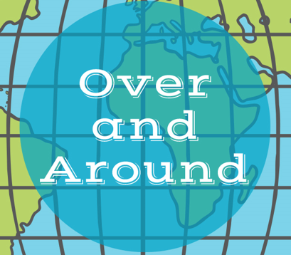
- Find the locations in the world with the coordinates given on the PowerPoint. | Within the co-ordinate, the ° stands for degrees and the ‘ stands for minutes:  Florida = 28°00'N 82°00'W,  which reads 28 degrees and zero minutes North, 82 degrees and zero minutes West.
- Complete the worksheets. If you don’t have an atlas to use you can use a world map, you can find one on the following website:  https://www.mapsofworld.com/world-maps/world-map-with-latitude-and-longitude.html | 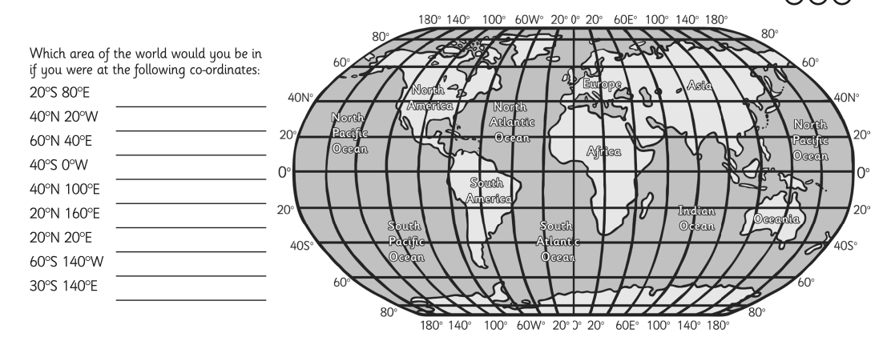  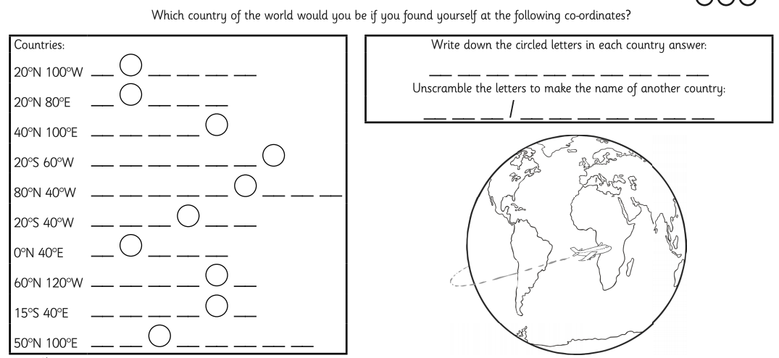
- Ask your parents/carers to tell you about some places they’ve been too or heard about. Can you locate them on the map? What are their co-ordinates? | ?!

