Class 7 Years 3 and 4: Topic.
Wb 13.04.20

Instructions:
- If you can, print out the blank map of the UK, showing the county boundaries. Look up the definition of a county on google. | 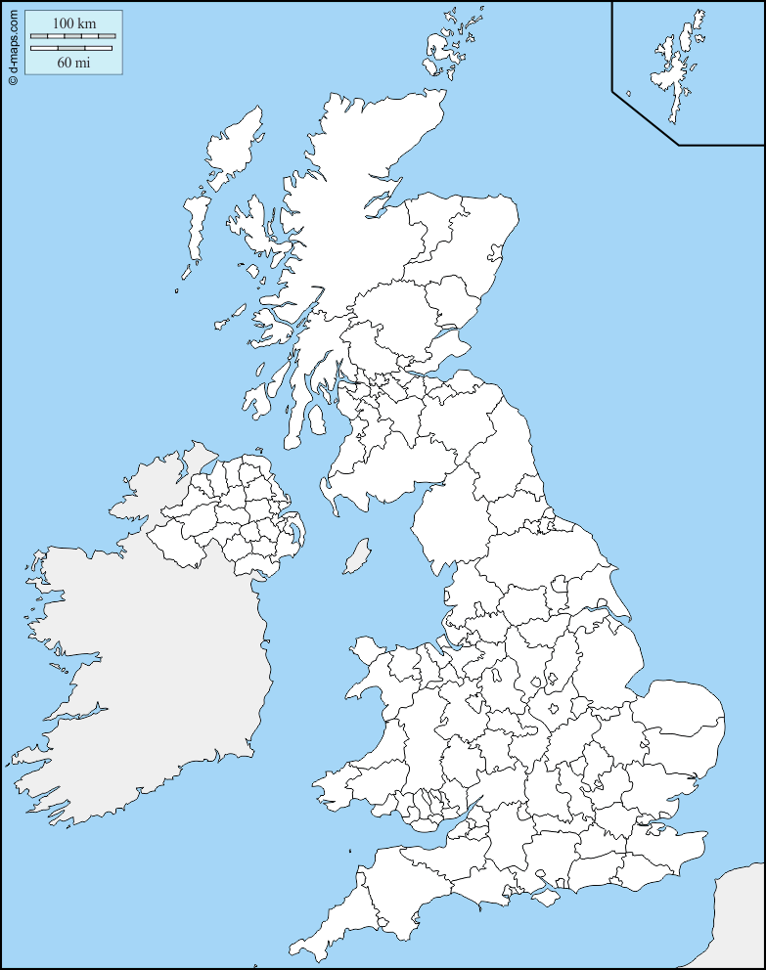
- Use google images to search for UK counties maps, then use this information to label the counties on your blank map. | 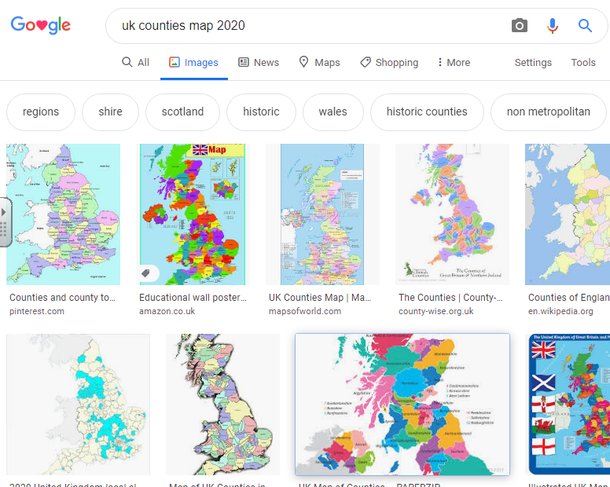
- Check your answers with the powerpoint called ‘Counties of England’. Then, using the 8 point compass, can you answer the questions about directions from one county to another? | 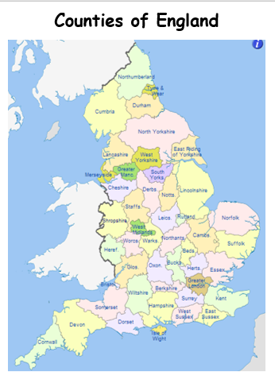
- Check your answers with the answer sheet from the powerpoint. No peeking!! | ?!

