Class 7
Topic – Britain 2

Your task is to locate and label the major cities in the British Isles and gain an understanding of which countries they are in – England, Scotland, Wales, Northern Ireland or the Republic of Ireland?

- If you can, pint out a copy of the British Isles from our website. | 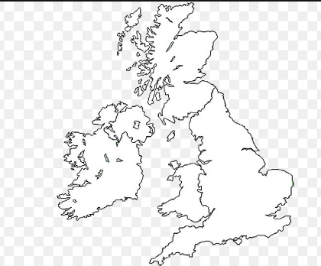
- Use:  https://www.britain-visitor.com/maps-britain/map-major-towns-cities-british-isles  to download a large map of the British Isles. Use this to locate these cities:  - London, Edinburgh, Cardiff, Belfast, Dublin.  - Liverpool, Manchester, Newcastle, Glasgow, Bristol, Birmingham, Hull, Leeds, York, Sheffield.  - Nottingham, Leicester, Canterbury, Dover. | 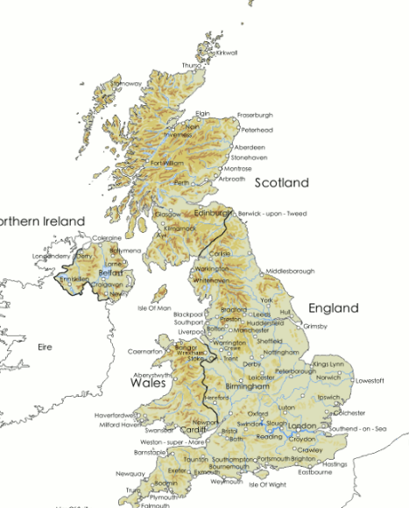
- Using the information, label your blank copy of the map, if you can. Colour the 5 countries a different colour.
- Use the eight-point compass to decide which direct you have to travel in to get from one city to another. How many combinations can you find? Plan a longer journey, visiting many cities along the way. See example: | - London to Edinburgh, North.  - London to Liverpool, North-west….

