Science Topic-Light Week beginning 8 June 2020
Lesson 1
L.O. I can explain that I need light to see things, and that dark is the absence of light.
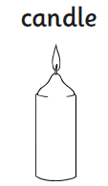
Look at the following items. Decide whether or not they are sources of light. Drag and drop them into the table below or you can just write the answers in the correct column.
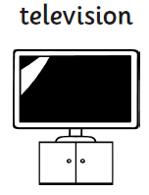
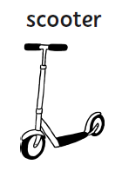
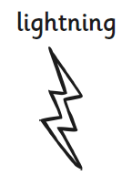
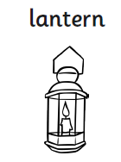
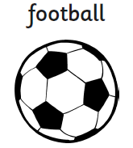
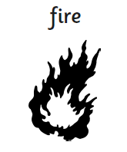
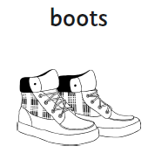
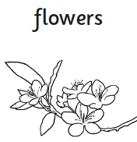

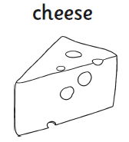
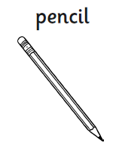
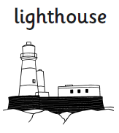
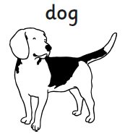
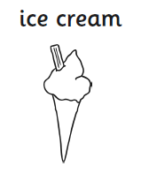
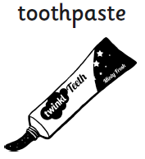
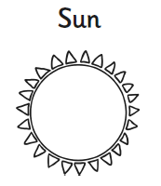
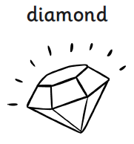
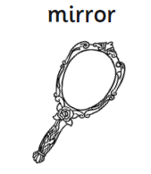
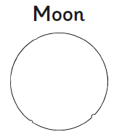
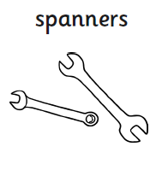
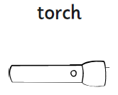
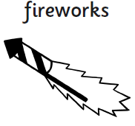
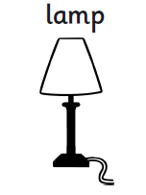
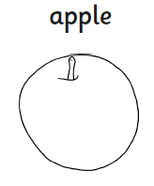
Source of Light Not a source of light

Check your answers.
Sources of light: candle, fire, lantern, lightning, television, sun, lighthouse, lamp, fireworks and torch.
Not light sources: flowers, boots, football, scooter, toothpaste, ice cream, dog, pencil, cheese, apple, spanners, Moon, mirror and diamond.
How many did you get correct? Did you put the Moon in the correct column? If not, try to find out why the Moon is not a source of light even though we can see it at night.

The moon is not a light source because it does not make its own light.
We can see the moon because light from the sun reflects off it (bounces off it) back to the earth.

Dark is the absence of light.
If there is no light from a light source, it will be dark.
Think about times when it is dark, or places where it is dark. Which sources of light are absent, or switched off?

_______________________________________________________________________________________________


Get an adult to put some 5 items in a bag so that you cannot see the items. Visit each one and feel the object inside. Write a description or draw a picture of what you think is inside the bag on the sheet.

1 | 2 | 3 | 4 | 5

Was it hard to tell what was in the bags?______________________________________________________________
It is much easier to use our eyes to see, but for this we need light.
How can we get light into the bags?__________________________________________________________________

Open up the bag.
The light can get inside now.
Which light source is illuminating the objects?________________________________________________
Visit the bag again now it is open to the light.
Use your sheet to draw or write about the objects that are really inside!
It is much easier to tell now because you can use the light to see.

Lesson 2
L.O. I can explain that I need light to see things, and that dark is the absence of light.

Watch the following videos and use them to help you fill in the gaps below.
Light source video
light source video 2
What is light? video



