Science- Forces Lesson 1 L.O. I can understand different types of forces.
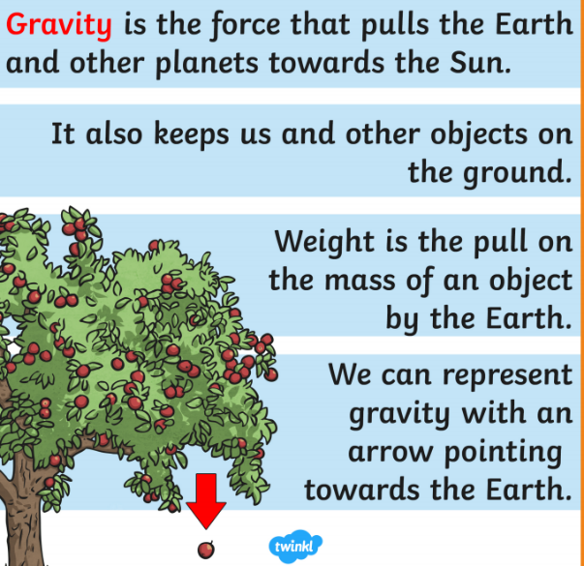
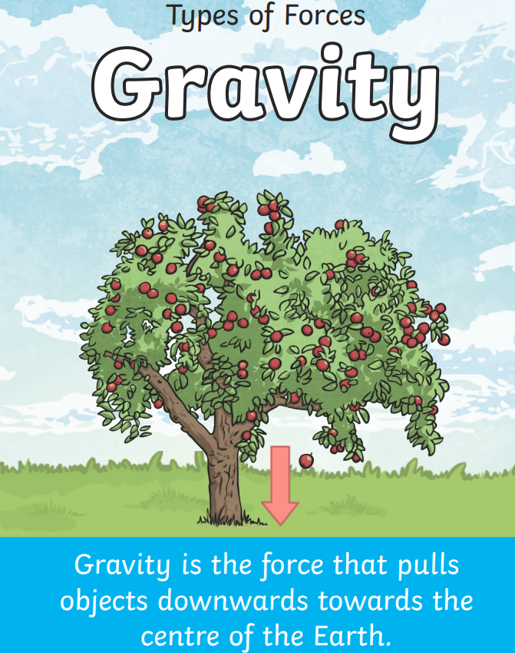
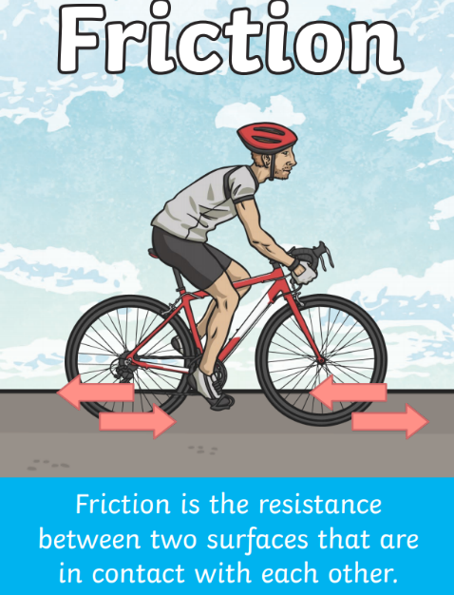
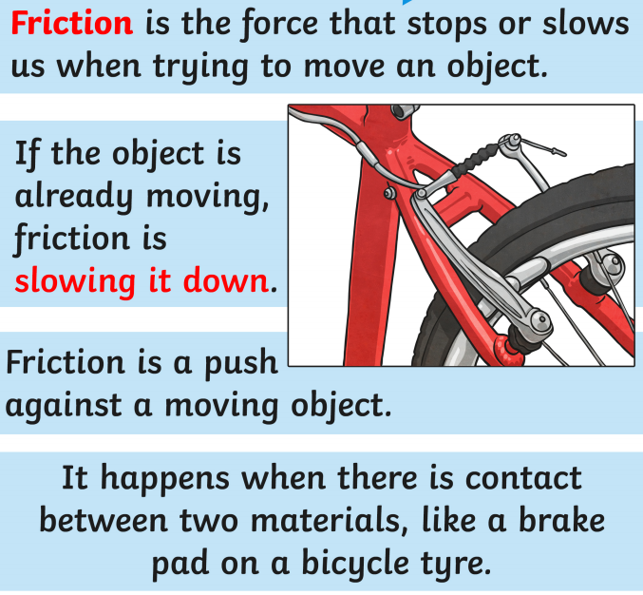
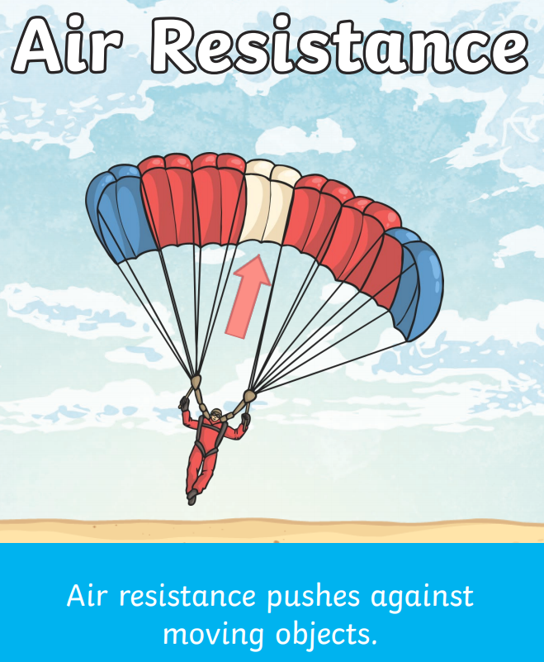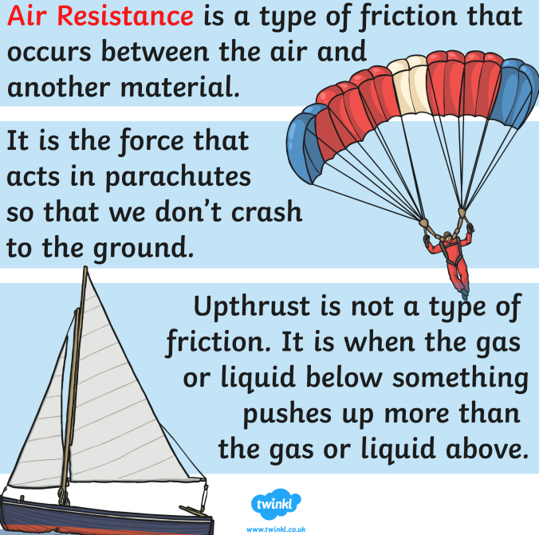

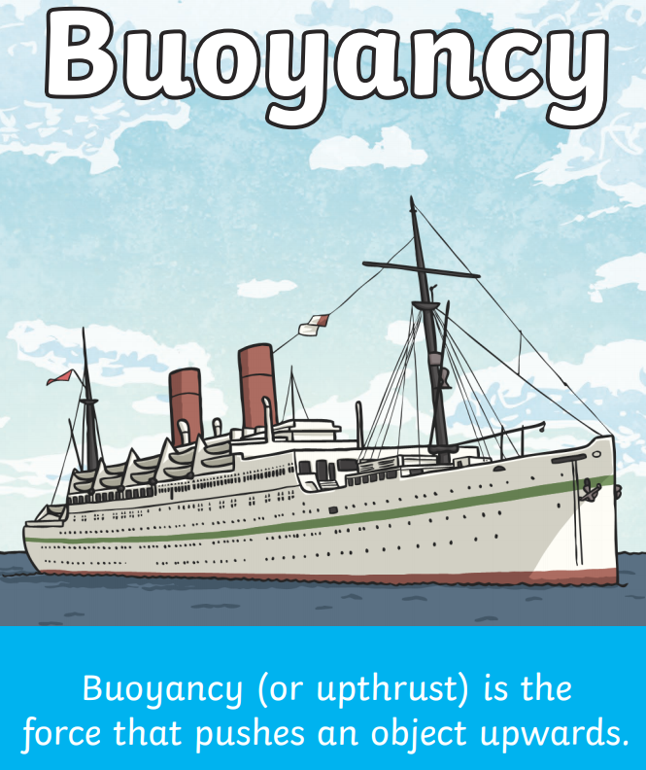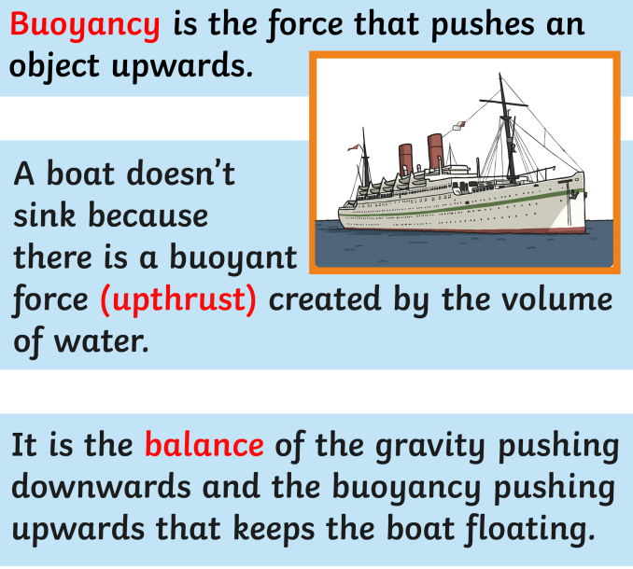

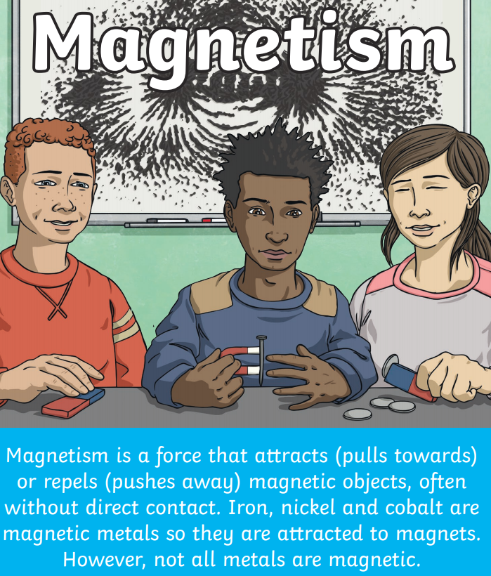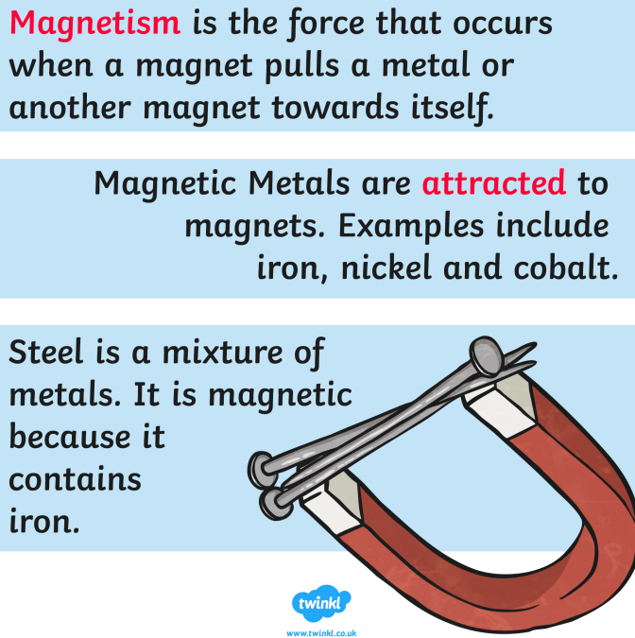

Watch these videos to help you understand the different types of forces.
https://www.youtube.com/watch?v=kmtDbF3b4ns
This is a website with 8 learning guides from the BBC that identifies the different forces. https://www.bbc.co.uk/bitesize/topics/zvr3nrd
Once you have finished watching all the videos, match the force to the definition.
The force when a magnet pulls a metal or another magnet towards it.
The type of friction that occurs between air and another object.
The resistance between two surfaces that are in contact with one another.
The force that pushes an object upwards.

The force that pulls objects towards the centre of the Earth.
Friction

Buoyancy/
Upthrust
Magnetism

Air/Water
Resistance
Gravity

Lesson 2 L.O. I can identify different forces in action.
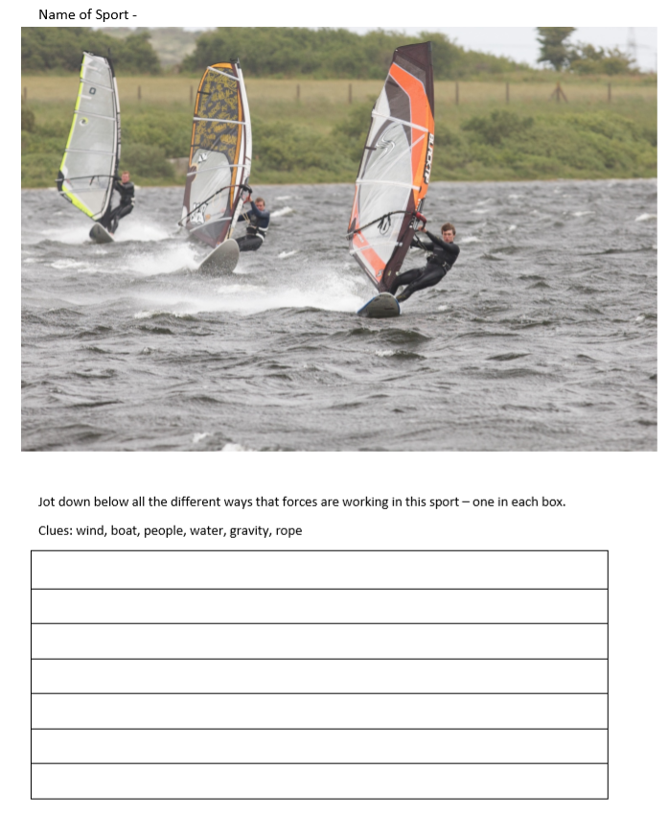
Review the forces from lesson 1 Look at the pictures of the following sports. Thinking about the forces that you learned about and try to identify the different forces taking place.


