Science-Forces
Lesson 1 Pushes and Pulls I can identify forces on objects.
A force is a push or pull acting on an object as a result of the object's interaction with another object. Forces can make objects stop or start moving.
Watch the following video to find out different types of forces.
https://www.bbc.co.uk/bitesize/clips/zch4wxs

Write down the different forces you saw in the video.

____________________ ___________________ ___________________

In the video, how did the get the car to go further? _______________________
_________________________________________________________________

Underneath the following pictures, identify if they are a ‘push’ or a ‘pull’.

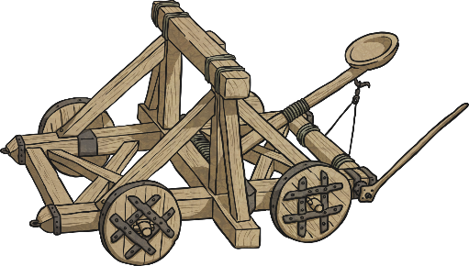
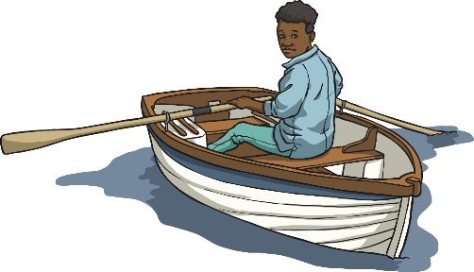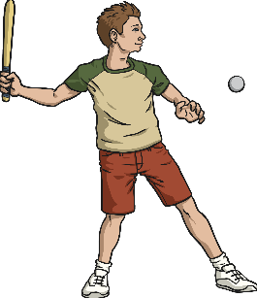
Rowing a boat Hitting a ball Preparing a catapult

______________________ __________________ ______________________
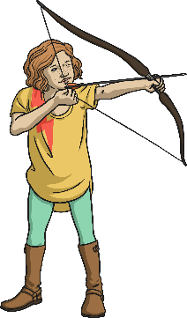
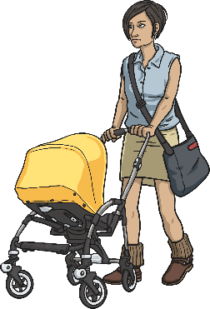
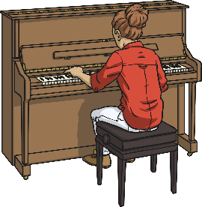

Preparing an arrow Playing the piano. Walking a baby in pram

__________________ _________________________ ____________________

Answers to Push/Pull pictures
Pull on the oars. Bat pushes the ball. Pull the catapult back.
Pull the arrow back. Push down on the piano keys. Push the pram.
Did you get them all correct?

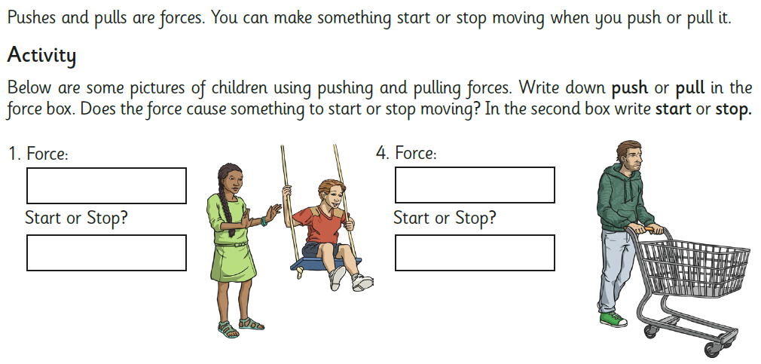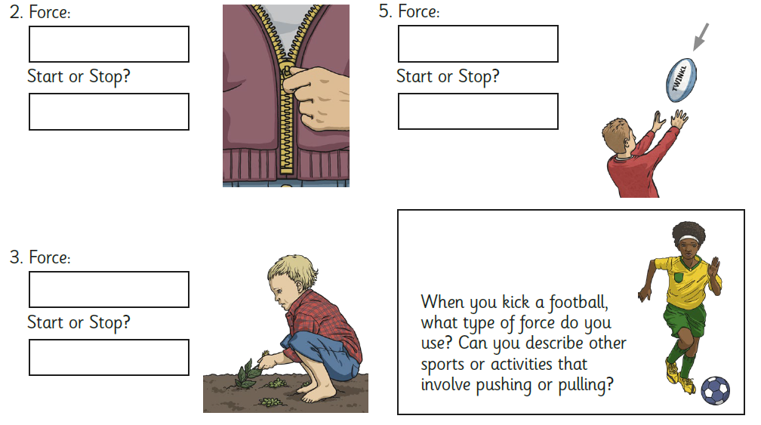
__________________________________________________________________________________________________________________________________________________________________________________________________________________________________________________________________________________________________
Answers to activity sheet 2 Push/Pull
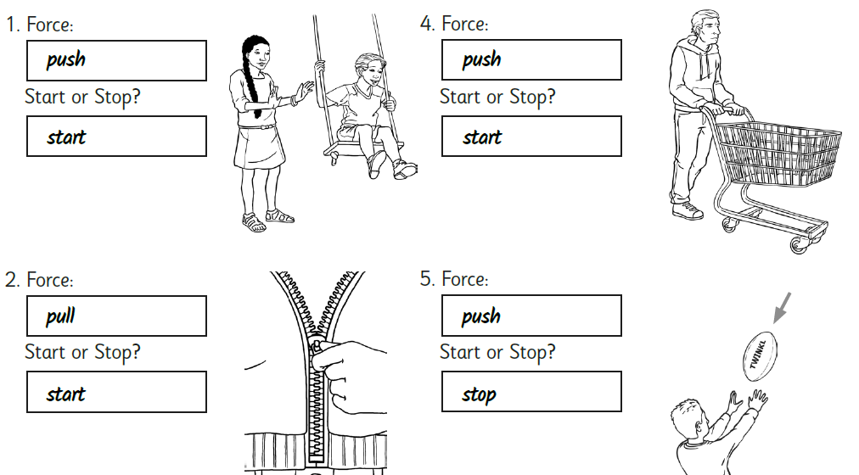

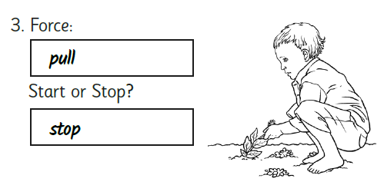

Lesson 2-Forces I can investigate the effects of friction on different surfaces.
Remember-
- Forces are pushes and pulls.
- These pushes or pulls will always change the motion of an object. They will either make it start to move or speed up, slow it down or even make it stop.

Cyclists sometimes travel over different surfaces.
By pushing the pedals harder or faster, he can change the motion of the bicycle. It will speed up.
When the cyclist pulls on the brakes, the brake pads will push on the wheels, changing the bicycle's motion. It will slow down, and eventually stop.
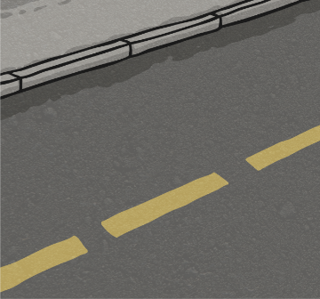
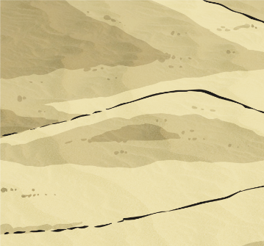
How do the different surfaces affect the motion of the bicycle?
Road
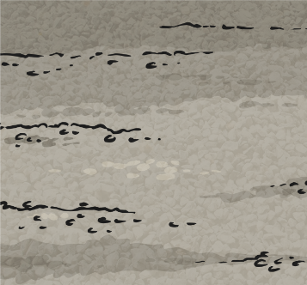
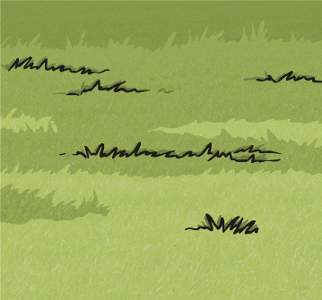
Grass

Sand
Gravel
Grass

_________________________________________________________________

_________________________________________________________________
_________________________________________________________________
_________________________________________________________________

These surfaces all exert a force on the bicycle. This force is called friction.
Friction is a force that holds back the movement of an object. Friction acts in the opposite direction to the movement of the object.
These surfaces all exert a force on the bicycle. This force is called friction. Friction is a force that holds back the movement of an object. Friction acts in the opposite direction to the movement of the object.

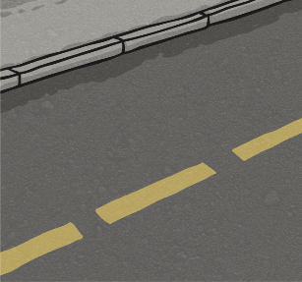
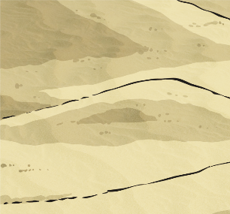
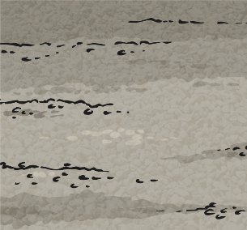
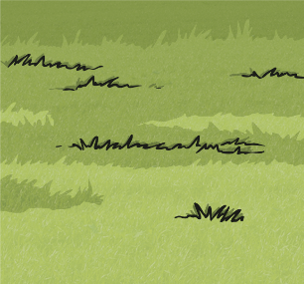
Grass
Gravel
Sand
Road
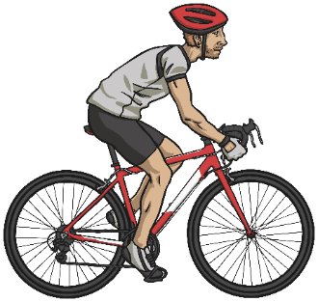
The driving force pushes the bicycle, making it move.
Friction from the surface (grass, gravel, sand and road) below pushes on the bicycle, slowing it down.


Different surfaces create different amounts of friction.
The amount of friction created by an object moving over a surface depends on the roughness of the surface and the object, and the force between them.

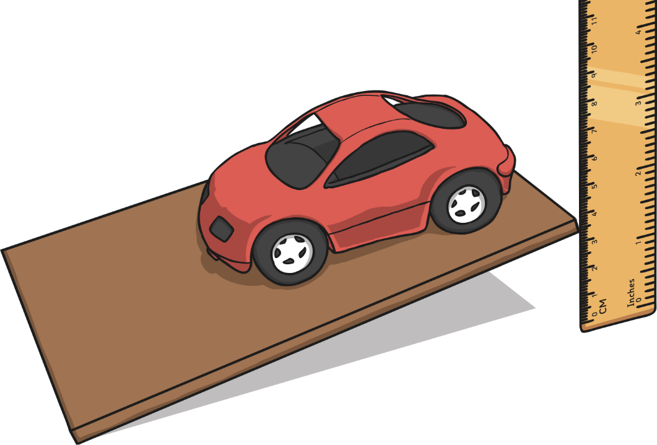
You are going to set up your own investigation into the amount of friction created by different surfaces. You don’t need to use the surfaces in the
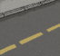
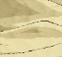
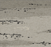
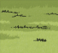
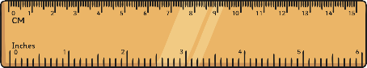
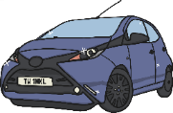
picture

You will use:
- A toy car

- Boards covered with different surfaces

- A ruler

- A rulera

- Place the car at the end of one of the boards.
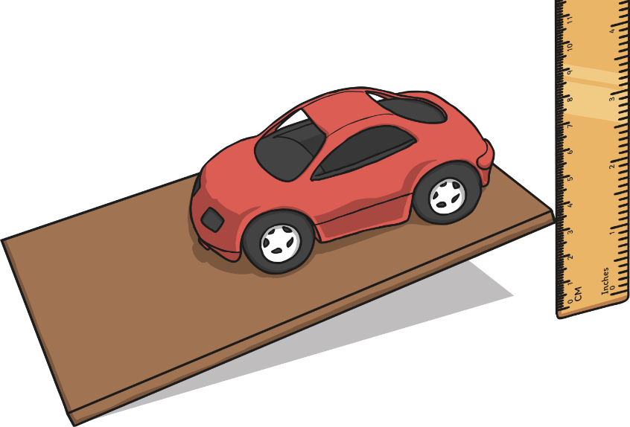
- Place the ruler at the side of the board, so you can measure the height of the board as you lift the end.
- Lift the end of the board that the car is on 1 cm at a time.
- Watch the car carefully, and notice at what height it starts to move.
- Try this with each of the boards covered with different surfaces.

As you lift the ramp, gravity will pull the car down.
Friction will be pushing opposite to this.
Surfaces that create a lot of friction will need to be lifted higher for gravity to overcome the friction and pull the car down the ramp.
Surfaces that don't create much friction will not need to be lifted much, as it will be easier for gravity to pull the car down.


