Lesson 1
L.O. To find out about the way new plants arrived in our country.
Plant Hunt
Plants are all around us. You will see plants in people's gardens, in parks, on roadsides and by footpaths.
What kind of plants can you find around your house or garden?

Look around your area to see which types of plants live there. Decide on a starting point and look carefully around to spot plants. If you know what a plant is called, write its name in a box below. If you are not sure what it is, draw a quick sketch of its leaves and flowers. Move to a different area to see if you can spot any different types of plants. You don’t need to write or draw the same plant twice, even if you see two examples of it. You may ask an adult to help you identify any plants you are not sure about.
Remember not to touch or eat any plants that you find.

Did you spot different types of plant? Where have all these plants come from?

Other plants are non-native. This means they have been brought here from different countries.

Some plants are native to Britain. This means that they have grown here for many years and have not been brought here from any other countries.

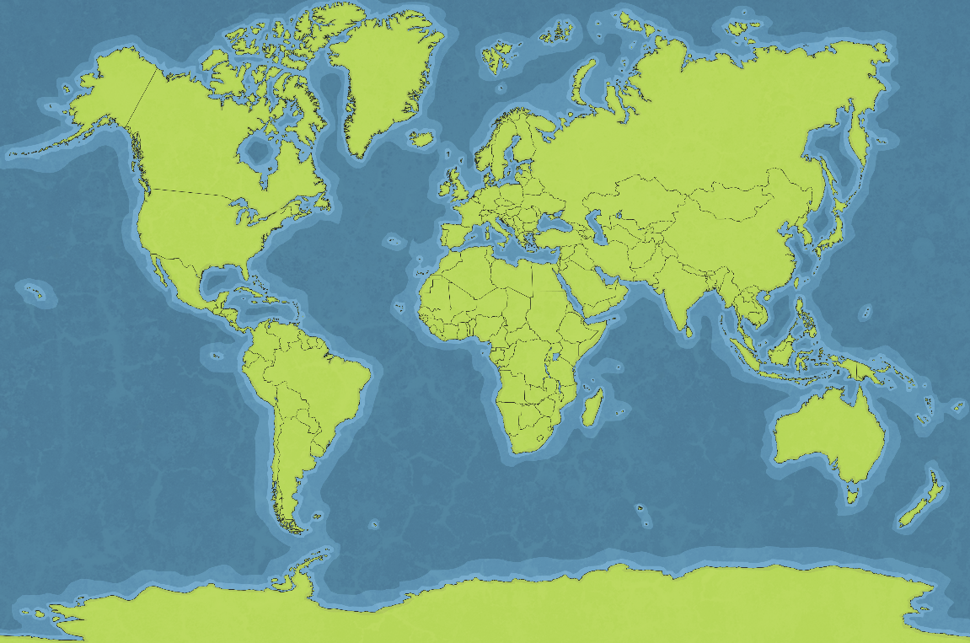
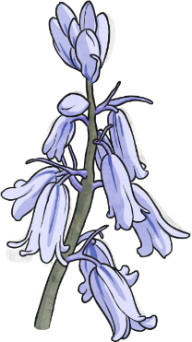

Native and Non-Native
Look at this garden and see where the different species of plants have originally come from.
Rhododendron
Asia and America
Wisteria
China, Korea, Japan, and North America
Honeysuckle native to the United Kingdom
Hollyhocks Asia

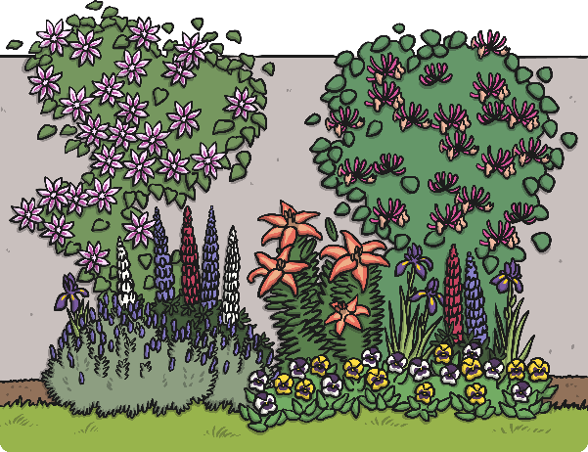
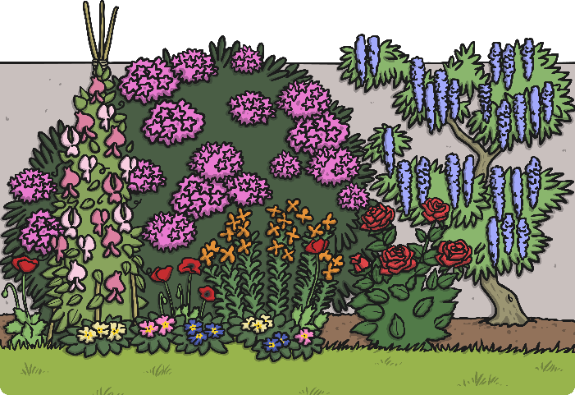
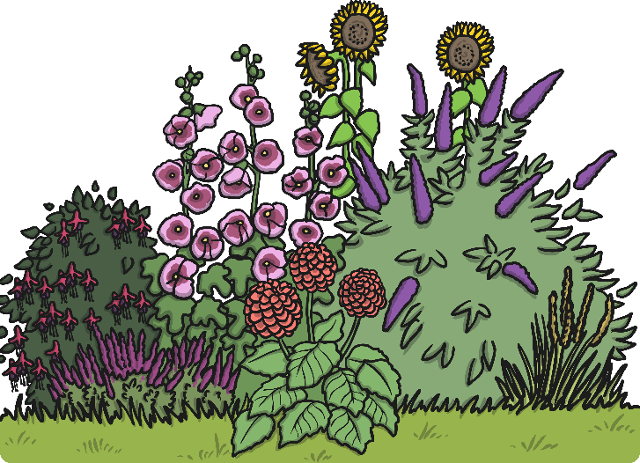

Buddleja America and Asia
Sweet Peas Italy and Greece
Lupin North America
Lily
Asia and North America
Lavender Southern Europe and Africa
Primrose native to the United Kingdom

Look at the plants above and where they came from. Open or look at the world map which is a different document, then try to identify their place of origin (where they came from).

How did the different species of plants get to the UK from these other countries?
Throughout history, men and women have travelled the world to find and bring back plants from far and distant places. They faced many different challenges to find, transport and care for these plants in order to introduce them successfully to the UK.

Let's find out about some of these famous plant hunters

The Plant Hunters

Sir Joseph Banks 1743-1820
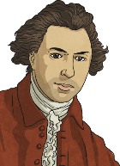
Joseph Banks was an English scientist who studied plants. He became famous when he took part in
Captain Cook's first voyage to Brazil, Tahiti, New Zealand and Australia. He was President of the
Royal Society for 41 years and advised King George III on how to set up the Royal Gardens at Kew. He introduced the eucalyptus, acacia and the banksia, which was named after him. Altogether, around 80 species of plants are named after him in some way.
David Douglas 1799-1834
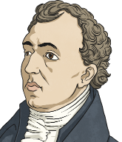
David Douglas was a Scottish botanist who worked at the Glasgow Botanical Gardens and the Royal Horticultural Society in London. He took part in three trips from England to North America. He
introduced the Douglas fir in 1827, as well as several other pines, fir trees, the lupin and the flowering currant. Douglas died on an expedition to Hawaii while climbing a mountain called Mauna Kea.

Jeanne Baret 1740 - 1807
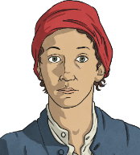
Jeanne Baret was a French woman who accompanied her partner, the botanist Philbert Commerson, on an expedition to South America, Tahiti and Mauritius. She was the first woman to sail around the world. Women were not allowed on board ships at that time so she had to disguise herself as a man to join the expedition. She and Commerson introduced the bougainvillea to Europe, as well as around 70 other plants. Only one, the solanum baretiae, was named after her.
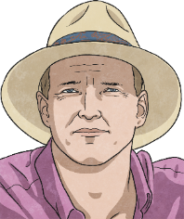
Tom Hart Dyke 1976 - Present
Tom Hart Dyke is an English horticulturalist and plant hunter. He is the designer of the World Garden at Lullingstone Castle. The World Garden contains around 8000 species of plants, many collected by Hart Dyke himself. Tom Hart Dyke was kidnapped on an expedition to collect a rare orchid in South America. He was held captive for nine months with his friend, Paul Winder. When he was released, he returned home and created his World Garden. He still hunts rare plants today.

Can you match the facts on your Plant Hunters Activity Sheet to the famous explorer?

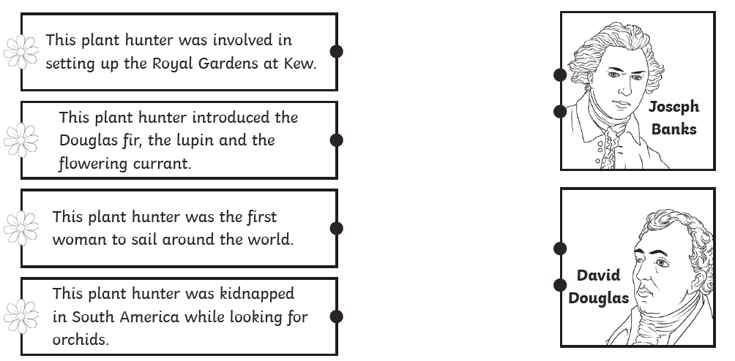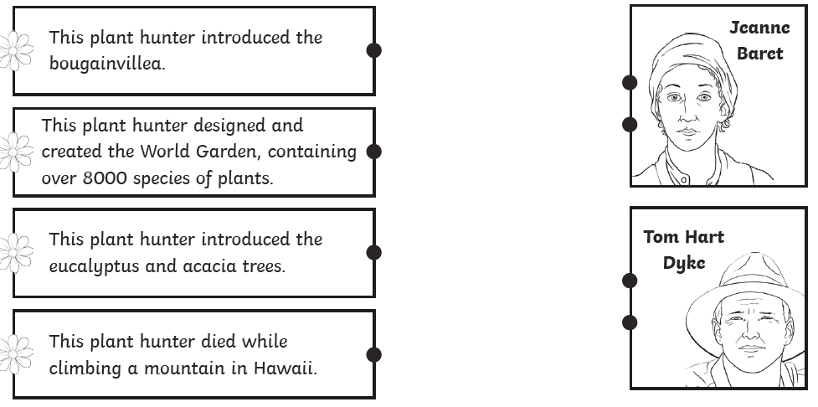

Answers-did you get them correct?
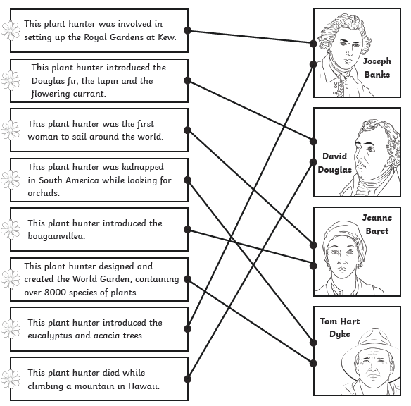
Lesson 2
Travelling Home
One of the biggest challenges for the plant hunters was how to look after the plants and seeds they collected on their way home. The early explorers faced long sea voyages of many months and they had to make sure that the plants stayed alive on board their ship.
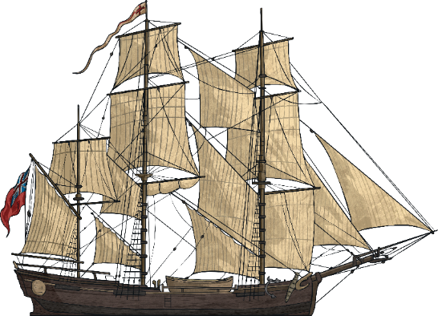
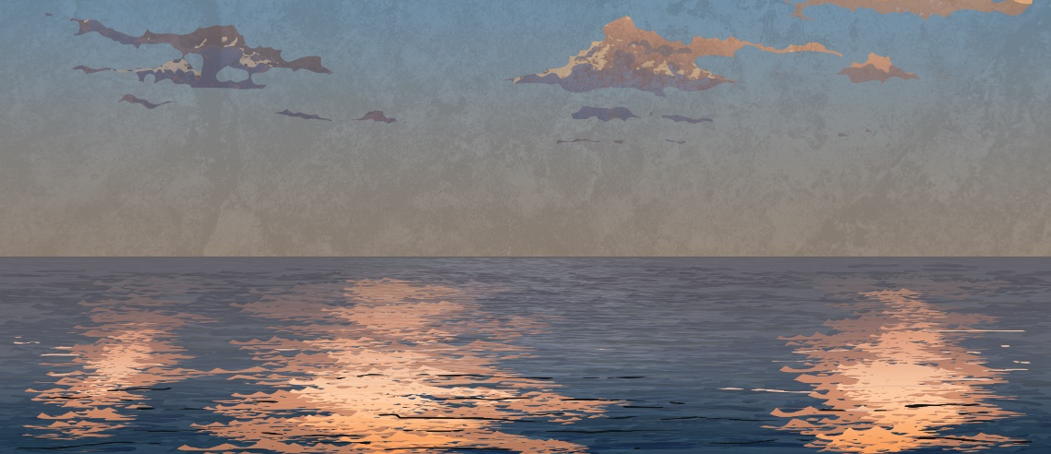

What do you think they would need to provide the plants with to make sure that they grew healthily on board the ship? Think about your knowledge of what plants need to grow.

___________________________________________________________________
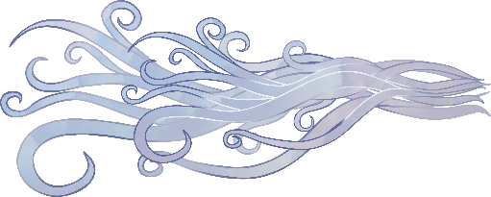

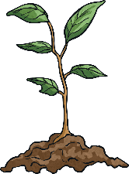


Light Room to grow Water Heat Air
Would any of these requirements be hard to provide on the ship? __________________________________
__________________________________________________________________________________________
What did Joseph Banks do to get his plants back safely?
Joseph Banks made sure that the ship he sailed on had special equipment to look after the plants and seeds he found.
He would have needed fresh water for the plants, a light and airy space for the plants to grow and enough heat to keep them healthy.
All these requirements cost a lot of money to provide. Joseph Banks spent £10,000 of his own money equipping the ship for his voyage!

Imagine that you are a plant hunter!
You have made a new discovery, finding a new plant that nobody has ever seen before.
What will you call it? What does it look like? How does it take in water and light? How will you care for it?
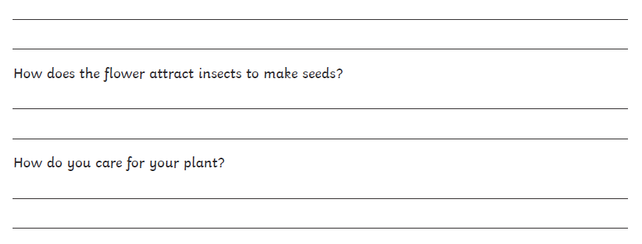
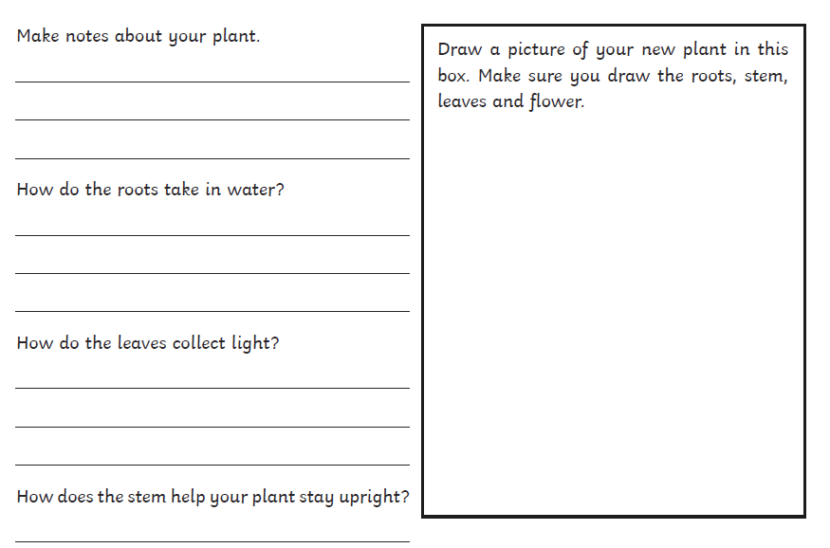
I can design my own new plant and explain how it lives and grows.

