Lesson 1 -Seed Dispersal
LO To find the different ways that plants disperse
This lesson is about Seed Dispersal. First of all, what do you think dispersal means. If we are looking at seeds what might it mean. Using a dictionary, find the meaning of the word dispersal.

Seed dispersal is when seeds are transported from the plant to another area in order to grow.
Can you think of any different ways that plants disperse their seeds?

Watch the two videos below. Then draw pictures and explain the different ways seeds can be dispersed.
https://www.youtube.com/watch?v=0h82aA8MOmc
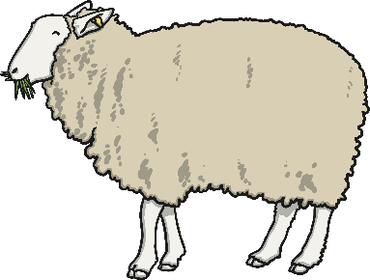

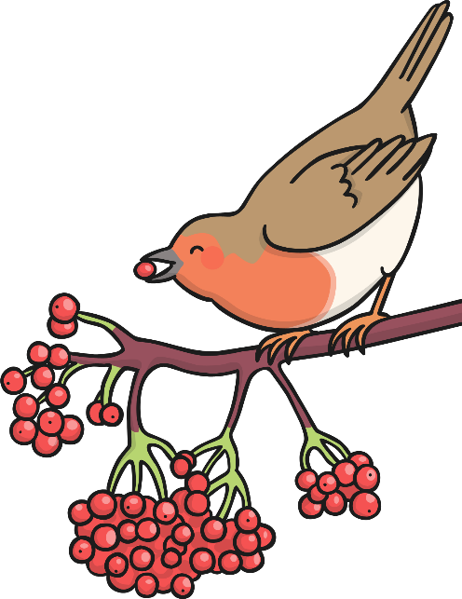
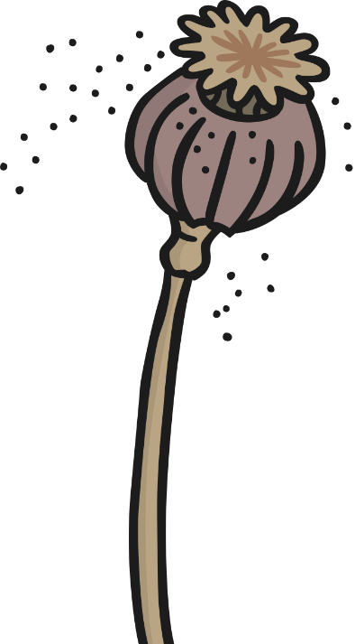
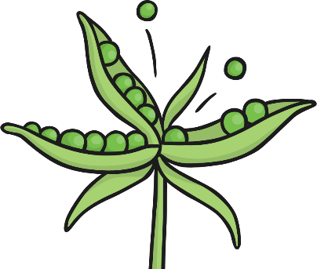
http://www.bbc.co.uk/learningzone/clips/seed-dispersal/2258.html
bursting
carrying
shaking
eating

Extension-explain why seeds need to be dispersed.

Lesson 2- Life cycle of a Plant
Watch the following videos about the lifecycle of a plant. Then complete the diagram on the next page.
https://www.bbc.co.uk/bitesize/clips/zgqyrdm
https://www.youtube.com/watch?v=Avrbtt7izP4
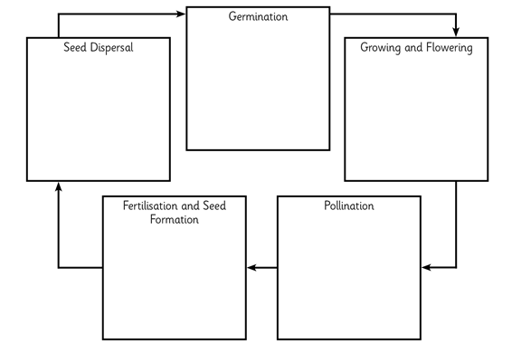
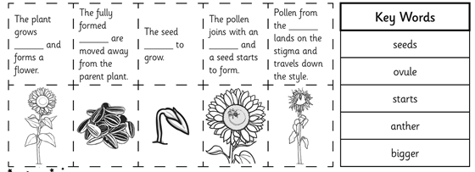
Use the descriptions and pictures below to describe the different stages of the plant lifecycle.

