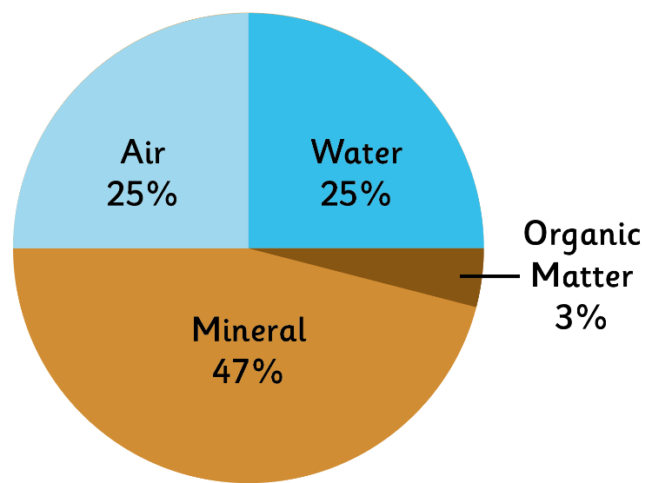
What Is Soil Made Of?
Air
Soil contains gases such as
carbon dioxide, oxygen,
nitrogen, methane and
radon.
Water
Air and water fill the gaps
between particles
of soil.
Organic Matter
Organic matter includes
both living and decaying
animals and plants.
Mineral
The minerals in
soil come from finely
broken down rock.

Soil is the uppermost layer of the Earth. It is a mixture of different things.

There are 4 main processes in soil formation.
1. Additions 2.Losses
Rainfall adds water.
Dust adds minerals.
Animal waste adds organic matter and nutrients.
Decaying plants and animals add organic matter.
Humans add fertiliser. Fertilisers contain minerals and nutrients. Natural fertilisers are made from animal waste and organic matter. Human-made fertilisers are made from chemicals.

Water evaporates (turns into gas when hot) into the air.
Soil particles can wash away in storms.
Organic matter can turn into the gas carbon dioxide.
Nutrients and Minerals are taken up by plants and can drain into groundwater.

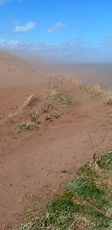

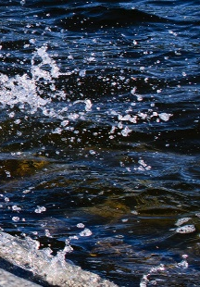

3.Translocations

Before you read about translocations. Look at the word and see if you can think of what might happen in this process. What does the prefix ‘trans’ mean and what does ‘location’ mean?
Translocations are movements within the soil.
Gravity pulls water down from top to bottom.
Evaporating water draws the minerals up from the bottom to the top.
Animals living in the soil move the soil around in every direction.
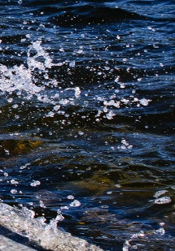

4.Transformations
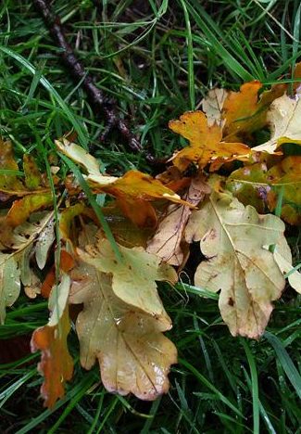
Before you read about transformations. Look at the word and see if you can think of what might happen in this process. What does the prefix ‘trans’ mean and what does ‘formation’ mean?
Transformations occur when something changes into something else.
Humus is what is left when dead leaves decompose.
Weathering causes hard rock to erode and turn into smaller and smaller pieces of rock.
Oxygen reacts with the minerals such as iron which can make the soil look a reddish, ‘rusty’ colour.

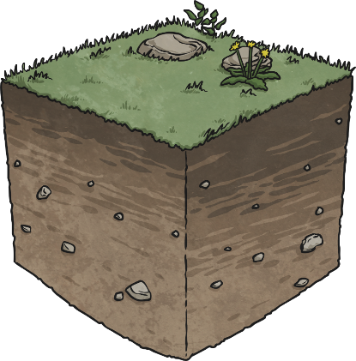
All four processes are taking place at the same time all the time!

Questions for Soil formation.
- What are the four things make up soil?
1. 2. 3. 4.
2. What is organic matter?
3. Where does soil get minerals?
4. Name for four processes of soil formation.
1. 2. 3. 4.
5. What different things are added in soil formation?

6. What is taken away in soil losses?

7. How do things move within the soil in translocation?

8. How does the soil change in transformation?

