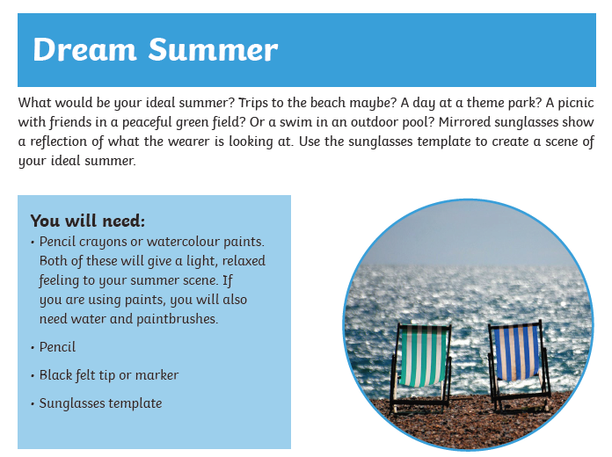
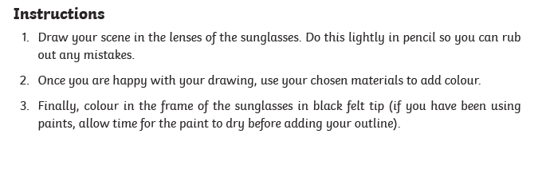
If you can’t photocopy the sunglasses below, you can try to draw them the best you can by yourself or ask an adult to help you.



