Geography Week beginning 22 June 2020
L.O. To create a key for a map of a school.
What is a key? A key unlocks something. So, what is a key for a map? A key for a map unlocks more meaning of a map.

Look at the following pictures. Of the two pictures side by side, circle which one is a symbol for a map?
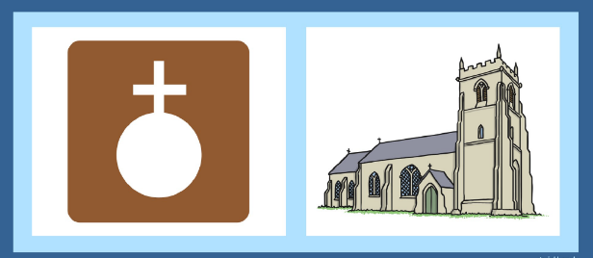
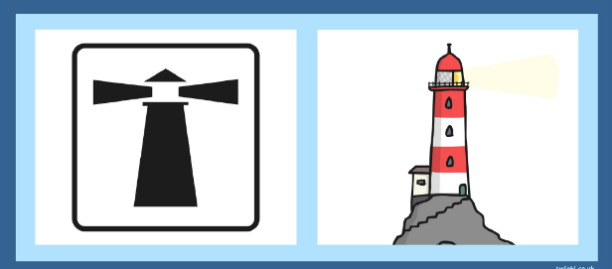

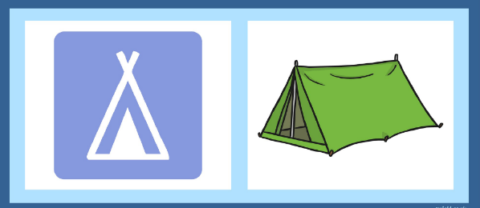
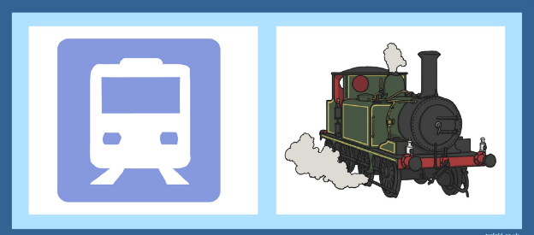

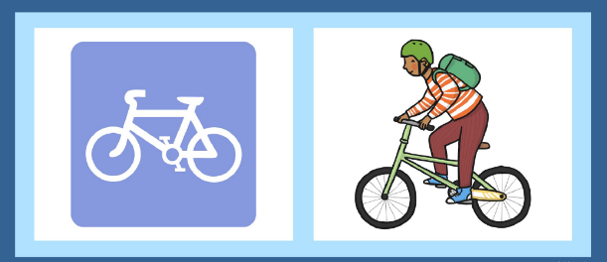
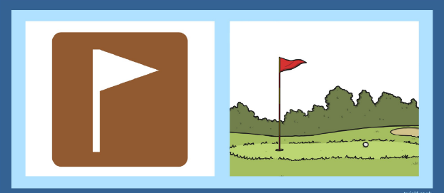

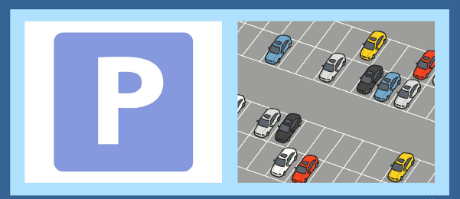
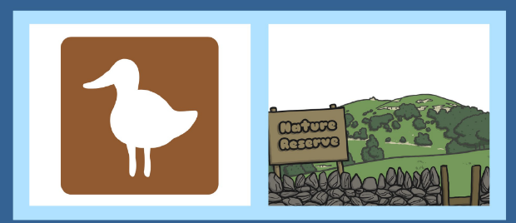

You should have circled the pictures on the left. What makes a good key symbol for a map?
Look at the symbols above, what do you notice about them?
They are simple in shape and only one colour. You are now going to design your own symbols for a map.

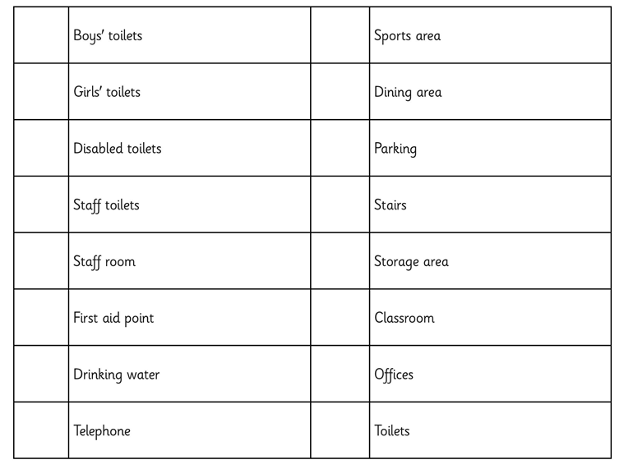
Create your own designs for the following areas of a school. Remember to keep your symbols simple and only one colour.

