Geography-Week beginning 8 June 2020 Lesson 1
L.O. l can use coordinates to identify position on a map.
Today you are going to be designing your very own island. In order for you to identify where you will position each feature, you will need to use coordinates. When reading/writing coordinates it is horizontal ,x, (down the corridor) then vertical, y, (up the stairs).

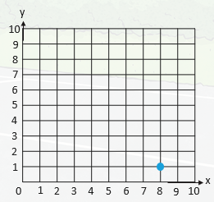
Look at the grid to the right. Using coordinates,
what is the position of the blue dot? Remember the X axis
first, then the Y axis.
( , )

Did you write, ( 8, 1)? If so, well done.

Design your own island using these instructions. Using the map on the next page, identify different positions on your island.
You will need to include:
- a river;
- an area of hills or mountains;
- small villages;
- a large town;
- a beach;
- any other locations you like.
Draw your features on the map and then write the coordinates of each location.
Location | Coordinates
 | ( , )
 | ( , )
 | ( , )
 | ( , )
 | ( , )
 | ( , )
 | ( , )
 | ( , )
 | ( , )
 | ( , )

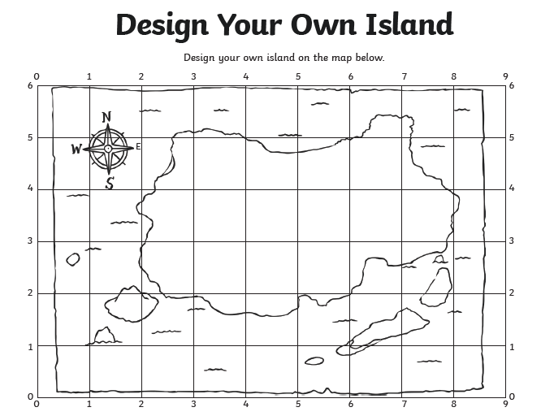

Geography Lesson 2
L.O. I can find the capitals cities of various countries.
Find the capital cities of the following countries. Remember to use a capital lettere when you write the name. How many of them did you know before looking them up? Put a star next to the ones that you knew beforehand.



