Topic-Machines Week Beginning 01.06.20
Lesson 1 I can understand how some machines work and what impact they have on life on Earth.
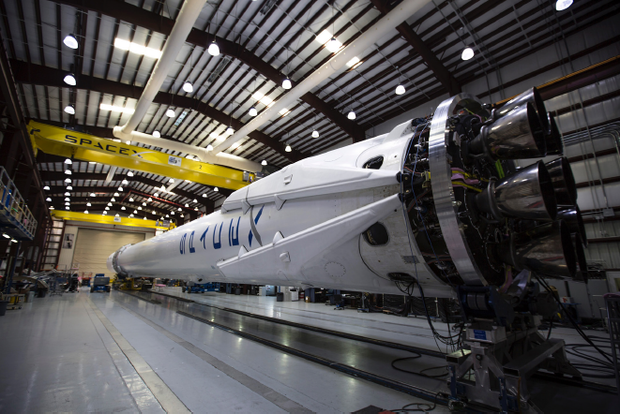

Think 
What is in the picture?_____________________
How do you think it works?____________________________________________________
__________________________________________________________________________
__________________________________________________________________________
Who do you think built it?_____________________________________________________
Where do you think it is going and why?_________________________________________
__________________________________________________________________________
Who would be going in it?_____________________________________________________
__________________________________________________________________________
What might it find?__________________________________________________________
__________________________________________________________________________

Solve
The first British astronaut was Dr Helen Sharman. She spent seven days on board the Mir space station. Mir orbited the Earth 15.7 times per day. How many times did Dr Sharman orbit the Earth? You may use a calculator to help you. _________________ To the nearest minute, how long did it take the Mir space station to orbit the Earth once?______________

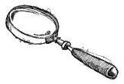
Discover
Fact: In 2010, the Isle of Man was ranked the fifth most likely nation to put the next person on the moon.
Question: How many countries have sent a person into space?___________________
Who was the first man in space?_______________________
Who was the first woman?___________________________
What was the longest time anyone has spent in space?____________________________
Which spacecraft has travelled furthest from Earth? ___________________________
How far has it travelled from Earth?____________________________________

Discuss 
Discuss the following questions with an adult.
Is space exploration a good thing?_______________________________________________
___________________________________________________________________________
___________________________________________________________________________
Should public money be invested in scientific research, such as space travel? ____________
___________________________________________________________________________
___________________________________________________________________________
How do modern lives rely on space and satellite technology?_________________________
___________________________________________________________________________
___________________________________________________________________________
___________________________________________________________________________
___________________________________________________________________________

Lesson 2
L.O. I can use my knowledge of a rocket creatively.
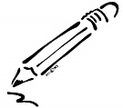
Respond
Write the introduction to a science fiction story. Who are the characters? Where are they? Where are they travelling to? Why?
Vary you sentence length and punctuation to create suspense. Try to include your knowledge of how a rocket works in your introduction. Your introduction could go up to blast off.
___________________________________________________________________________
___________________________________________________________________________
___________________________________________________________________________
___________________________________________________________________________
___________________________________________________________________________
___________________________________________________________________________
___________________________________________________________________________
___________________________________________________________________________
___________________________________________________________________________
___________________________________________________________________________
___________________________________________________________________________
___________________________________________________________________________
___________________________________________________________________________
___________________________________________________________________________
___________________________________________________________________________
___________________________________________________________________________
___________________________________________________________________________
___________________________________________________________________________
___________________________________________________________________________
___________________________________________________________________________
___________________________________________________________________________
Reimagine 
Design your own rocket.
How would it fly?_______________________
How would it land?___________________________________________________________
___________________________________________________________________________
How would it be controlled?___________________________________________________
__________________________________________________________________________
__________________________________________________________________________
You could use recycled materials to build a model.
Draw a diagram of how your rocket may look.

