Where are the Wombats?
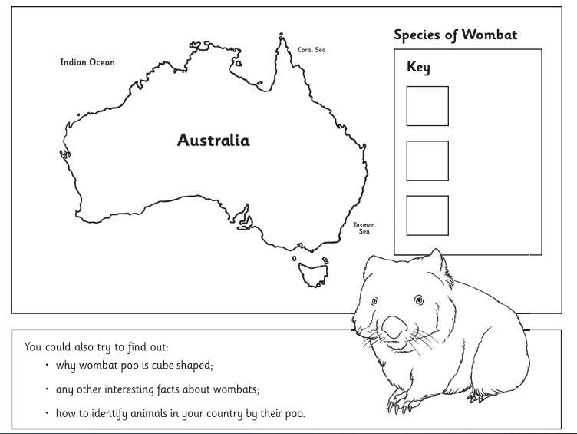
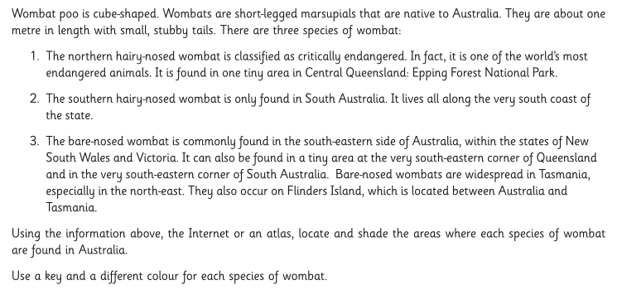
If you want, you can complete this on the sheet without printing it out. You can go to Insert shapes and choose a square shape for the key. Draw the square on one of the key squares, then format the shape to change the colour of it. Next, right click on the shape and choose format shape. Find the Fill tool in Format, then choose the colour of your choice. To highlight where the wombat is found, you can use the scribble line in shapes but make sure you do a complete shape.

