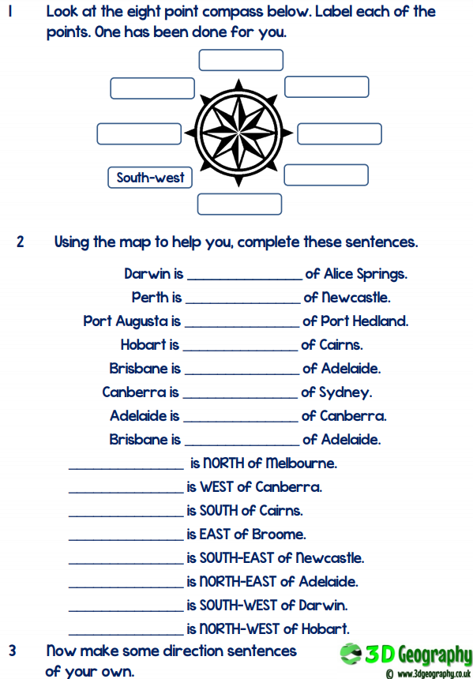
L.O. To use points of a compass to how direction on a map.
In this activity, you will need to use the points of the compass and the map below to answer the questions.
For part one, make sure you check your answers before you begin parts 2 and 3.

To complete part 2 correctly, it will help you to find the “of city” first and then use the compass to find the direction of the city at the beginning of the sentence. For example for the first one, find Alice Springs and then find Darwin. Which direction do you need to move to get to Darwin?


