Aboriginal Art

Aboriginal people are indigenous (the first) Australians. They tell stories in words and pictures about how the world began. They call this Dreamtime. Their stories are called ‘Dreamings’.
Aboriginal art uses 'Earth Colours'.

These are the colours of the desert. Aboriginal artists made their paints from natural materials.
Aboriginal paintings also use lots of dots. They used their fingers or sticks. There weren’t any art shops where they could buy brushes!
Aboriginal art includes lots of symbols for the natural things around them.
Below are some symbols of Aboriginal Art. Look in the picture and look for the symbols in the picture before reading the text.
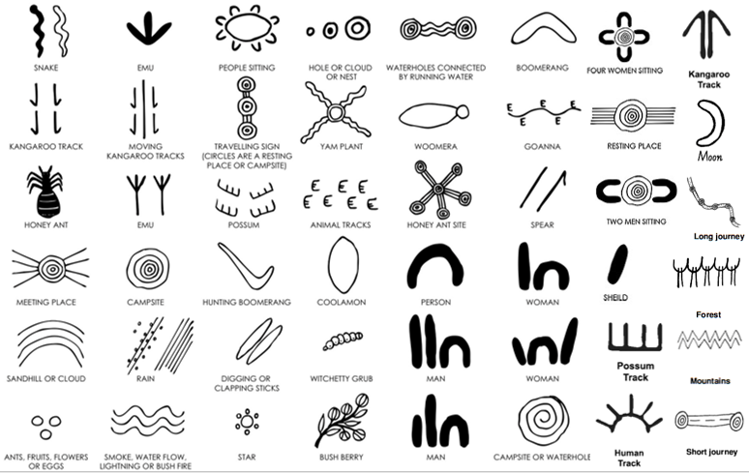

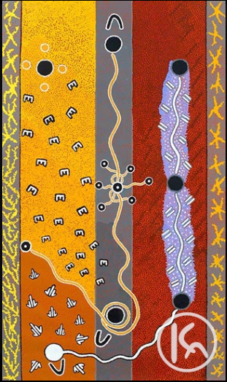
This painting is a good example of an Aboriginal painting rich in Aboriginal symbols. This painting is titled Kangaroo, Rain, Flying Ant, Possum Dreaming. The bottom left of the painting shows the kangaroo tracks around a campfire (white circle). The smoke (white line) rises from the fire into the sky creating rain clouds (purple sky with symbols for rain). In the centre of the painting is the flying ant which moves to form a new colony when the rains come. The possum tracks are shown on the left side of the painting in the yellow section.
The U shape reflects the mark left behind by a person. Groups of U shapes would indicate a meeting place for aboriginal people sitting around a campsite.
The gender of the aboriginal people is determined by what is associated with this symbol. For example spears would indicate a group of men.

Watch the following YouTube video showing you how to make an Aboriginal Art Painting. You were given paper in your first learning pack that you will be able to use for this activity. Watch the video first then decide whether you want to do the activity as shown or design your own artwork using aboriginal symbols. If you don’t have paints, you can use coloured pencils.
https://www.youtube.com/watch?v=8RZzLEoMCQE

